 |  | Jurnal Polimesin
 |  | Department of Mechanical Engineering
 |  | State Polytechnic of Lhokseumawe
 |  | http://e-jurnal.pnl.ac.id/polimesin
e-ISSN | : 2549-1999 |  | No. | : 3 | Month | : June
p-ISSN | : 1693-5462 |  | Volume | : 24 | Year | : 2026
Processing dates: received on 2025-12-18, reviewed on 2026-1-19, accepted on 2026-05-13 and online availability on 2026-06-30
Effect of GTAW current variation on the mechanical properties and microstructure of Al-6061/Al-7075 dissimilar welds
Surya Dharma^{1,*}, Rahmawaty¹, Rihat Sebayang¹, Yetti Meuthia Hasibuan² , Syita Nabila Tazkia¹
¹Department of Mechanical Engineering, Politeknik Negeri Medan, Medan 20155, Indonesia
²Department of Industry Engineering, Universitas Harapan Medan, Medan 20143, Indonesia
*Corresponding author: suryadharma@polmed.ac.id
Abstract
Aluminum and its alloys serve as foundational materials in the manufacturing industry, particularly in the aerospace, marine, and automotive sectors. While dissimilar welding is one of aluminum alloys’ most widely used joining techniques. This study assesses the impact of different welding currents (140 A, 150 A, and 160 A) on the Gas Tungsten Arc Welding (GTAW) of dissimilar Al-6061 and Al-7075 in terms of the mechanical properties (tensile strength and hardness) and microstructure of the welds. Tensile testing showed that a maximum tensile strength of 42.83 N/mm² was recorded at a welding current of 160 A, while a minimum strength of 22.66 N/mm² was seen at 140 A. All tensile specimens exhibiting failure also showed complete fracture within the weld zone, which suggests that the weld region is the predominant failure location. Vickers microhardness testing indicated the Al-6061 base material exhibited the most excellent hardness of 111.2 VHN (160 A) and decreased in the Heat-Affected Zone (HAZ) to 54.7 VHN in the weld metal. Moreover, hardness values averaged higher at 150 A compared to 140 A and 160 A. Microstructural examination at 500× revealed two main constituents in the weld joint: an aluminum solid solution (white) and the Mg₂Si compound (black), which plays a significant role in the mechanical properties of the weld. The result of the study demonstrates the importance of adjusting welding parameters, particularly current strength, to attain the desired mechanical properties and ensure the structural integrity of various welded aluminum alloys.
Keywords:
Al-6061, Al-7075, dissimilar welding, mechanical strength, microstructure.

Introduction
Aluminum alloys are widely used in the aerospace, marine, and automotive industries because of their considerable benefits. They are fairly lightweight with a high strength-to-weight ratio, making them ideal for applications where weight is critical [1, 2]. This material is widely used due to many valuable properties, such as exceptional corrosion resistance, lower density compared to steel and good electrical conductivity. These properties make it suitable for applications that require weight reduction and durability [3, 4]. In manufacturing processes, joining techniques for materials are important, particularly welding for component assembly. A notable development in welding technology that can join dissimilar metals is called dissimilar metal welding. In order to meet the strict performance requirements of some industries, this innovative approach has been used increasingly [5, 6]. Al-6061 and Al-7075 are among the various aluminum alloys commonly used in aerospace engineering, emphasizing the fabrication of aircraft structures and wings. These alloys possess excellent formability, high strength, and superior corrosion resistance, indispensable properties for elements exposed to extreme environmental conditions and mechanical loads [7, 8]. The aforementioned points are important for engineers and manufacturers to make high-quality, long-lasting application connections. These two aluminum alloys’ different physical and mechanical properties, which arise from their unique chemical compositions, can cause substantial differences in the strength and integrity of welded joints [7, 9]. Therefore, the interaction between all these factors needs to be considered during welding to optimize performance and dependability in the ultimate product. Engineers need to understand how these materials behave when welded.
Gas Tungsten Arc Welding (GTAW)-known as Tungsten Inert Gas welding-has long been a preferred technique for joining aluminum plates and extrusion [10, 11]. A non-consumable tungsten electrode establishes the arc, and welders manually feed the filler wire as needed. Inert shielding gas, nearly always argon or a helium blend, blankets the molten pool to exclude airborne contaminants. That protective atmosphere is vital because freshly exposed aluminum oxidizes almost immediately, forming a film that weakens any bond [12, 13]. Fine arc control allows operators to dial in heat precisely, a quality that aerospace inspectors routinely demand. Gas-tungsten-arc welding is frequently praised for its clean bead and fine control. Even experienced welders can encounter defects such as porosity, undercutting, or incomplete fusion when working with aluminum, which generally affects the strength and durability of the metal. However, these problems are primarily the result of some controllable input parameters. Adjusting factors like amperage, travel speed, or even filler alloy can significantly enhance the quality of a weld [14-16].
Dissimilar welding involves joining two metals with different physical, chemical and mechanical properties. It is commonplace in the aerospace, automotive, and power sectors where interfaces are formed between steel and aluminum, nickel alloys with titanium, or stainless steel with carbon steel [17, 18]. The major obstacles concerning dissimilar welding rest on differences in melting points, thermal expansion coefficients, thermal conductivity, and microstructure compatibility, which can result in cracking, porosity, and the formation of brittle intermetallic phases [19, 20]. Specific welding techniques such as TIG, MIG, laser or friction stir welding, controlled heat input and filler material selection are needed to resolve these matters. Strong, reliable, durable joints that can withstand structural and functional loads require a thorough understanding of metallurgy, process parameters, and dissimilar welding techniques [21, 22].
Çevik (2018) studied GTAW on 3 mm thick 7075-T651 aluminum alloy with different welding currents. The study examined the effect of welding parameters on the macrostructural and microstructural characteristics of the weld zones, which showed larger grain sizes with increased heat input, causing micro-cracks and leading to poor mechanical properties like hardness and impact strength [23]. On another study, Kotari (2020) conducted more advanced research focusing on optimizing GTAW and Friction Stir Welding (FSW) of aluminum alloys, specifically AA6061 and AA7075. This study utilized an L9 orthogonal array for experimental design. FSW resulted in higher tensile strength (151 MPa) than GTAW due to stronger Mg-Si precipitate formation in FSW samples. It emphasizes the importance of choosing appropriate welding techniques that maximize the mechanical performance of aluminum alloys [24]. Bansal (2021), has substantially contributed to our understanding of the welding parameters by studying the effects of GTAW on 5 mm thick AA6061 samples. The research was conducted according to American Welding Society standards and used MGS 525/409 as a filler metal. Notably, at 160A, tensile strength reduced significantly (105 MPa) and yield stress (245 MPa), while higher welding currents increased hardness in different zones. Microstructural examination of the weld region revealed fine equiaxed grains, leading to increased bending strength [25]. Furthermore, Fouad (2024) carried out an additional investigation concerning how various wires influence the quality of AA7075 aluminum alloy welds using GTAW. This study compared ER5356, ER4043, and ER4047 filler metals, and it was found that ER5356 had the finest grain structure with superior mechanical properties, including the highest ultimate tensile stress and hardness values. However, the ER4047 filler showed coarser grains and lower hardness, indicating the significance of selecting appropriate fillers for attaining optimum weld performance [26]. Lastly, Dada (2024) provided a broader perspective on aluminum alloy joining methods that included both traditional techniques such as welding and brazing as well as modern ones such as friction stir welding and laser beam welding. The study also acknowledged the ongoing research to improve the mechanical performance and structural integrity of materials. It is hoped that further studies will be conducted on alloy design and new technologies in order to enhance the application of aluminum alloys in future engineering challenges [21].
A significant research gap exists in the literature regarding the specific effect of welding current variation on dissimilar GTAW joints between Al-6061 and Al-7075, particularly with ER4043 filler. Most prior studies have focused on similar-alloy welding or have not systematically investigated the interrelationship between current strength, microstructural evolution (grain size and Mg₂Si precipitation), and the resulting mechanical properties in these dissimilar joints.
In previous studies, there has been a lack of available data on the impact of current strength on welding between Al-6061 and Al-7075. This lack of information is significant, given that these two aluminum alloys play a crucial role in various industrial applications, such as aerospace and automotive. Al-6061 is known for its excellent corrosion resistance and adequate mechanical properties, making it commonly used in structural applications. On the other hand, Al-7075 is recognized for its high strength-to-weight ratio, making it ideal for applications requiring greater strength. It is crucial to understand how variations in current strength can affect the dissimilar welding process between these two different alloys, as this directly impacts the quality and performance of the weld produced. Additionally, weld characteristics, such as tensile strength, ductility, and crack resistance, can vary significantly depending on the current strength applied during welding. Therefore, the objective of this study is to evaluate the impact of current strength on the dissimilar welding of different aluminum alloys, namely Al-6061 and Al-7075. The filler metal used is ER4043 with GTAW technique. The findings of this study have the potential to produce more efficient welding techniques and high-quality end products in industries that frequently use these materials.

Research methodology

Material
In this study, a GTAW process was carried out for the two different kinds of Base Material (BM) to examine the optimal joint strength of the workpiece (Fig. 1). The two base materials used in this investigation are commercially available, Al-6061 and Al-7075, with dimensions of 150×150×6 mm (length × width × thickness). The gas tungsten arc welding is carried out with the help of filler material ER 4043. Table 1 shows the chemical composition of base material Al 606, Al-7075 and filler metal ER4043.

Table 1. Chemical composition Al-6061, Al-7075 and filler metal ER4043
Elements | Al-6061 | Al-7075 | ER4043
Al | Bal | Bal | Bal
Si | 0.42 | 0.4 | 4.5-60
Fe | 0.42 | 0.5 | ≤ 0.8
Cu | 0.12 | 1.6 | ≤ 0.3
Cr | 0.19 | 0.23 | -
Mn | 0.05 | 0.3 | ≤ 0.05
Mg | 0.63 | 2.5 | ≤ 0.05
Zn | 0.02 | 5.3 | ≤ 0.1
Ti | 0.08 | 0.2 | ≤ 0.2
Other | - | 0.15 | -

Note: chemical composition data for Al-6061 and Al-7075 are sourced from the material manufacturer's specification (mill certificate). The ER4043 filler metal composition is based on AWS A5.10 standard specifications.

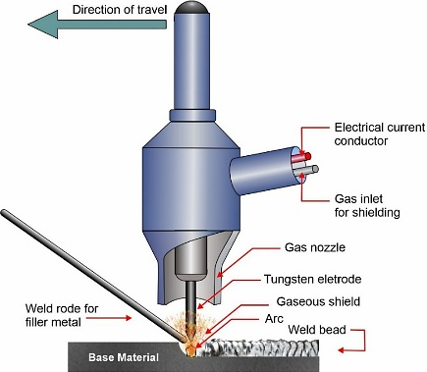
Fig. 1. GTAW schematic diagram.

Method
In the literature, there has been a lack of available data on the effect of current strength in welding Al-6061 and Al-7075. This lack of information is significant, given that these two aluminum alloys are vital in various industrial applications, including the aerospace and automotive sectors. Aluminum alloy Al-6061 is well-known for its excellent corrosion resistance and adequate mechanical properties, making it commonly used in structural applications [27]. On the other hand, aluminum alloy Al-7075 is known for its high strength-to-weight ratio, making it highly suitable for applications requiring greater strength [28]. In GTAW, the success of the process is highly dependent on selecting appropriate welding parameters and the correct type of filler metal. These parameters include, for example, electric current, voltage, welding speed, and shielding gas flow [29, 30]. In addition to welding parameters, the selection of filler metal also plays a crucial role. The type of filler metal selected must be adapted to the base material to be welded, as well as the alloy composition. The right choice will ensure the strength and durability of the welded joint [31, 32].
In this study, the filler metal type ER™ 4043 was used. This filler metal contains silicon (Si) as one of its alloying elements. The presence of silicon in ER 4043 significantly improves the welded joint’s mechanical properties after the welding process is completed. Silicon plays a role in forming magnesium silicide (Mg₂Si) compounds in the weld structure. Through a precipitation-strengthening mechanism, these compounds enhance the welded joint’s tensile strength, yield strength, and hardness. Thus, the use of ER 4043 not only facilitates the welding process but also produces stronger and more durable joints [33, 34]. The welding process is carried out using a Migatronic 300 machine in manual mode, which provides greater precision control during the welding process. High-purity argon gas (99.999%) is a shielding gas, protecting the weld area from contamination and oxidation, resulting in clean and high-quality welds. A pure tungsten electrode with a diameter of 2.4 mm is used due to its excellent conductivity and stability, making it ideal for achieving a consistent weld arc during welding. Two-column layout with a width of 96 mm and column spacing of 6 mm. Before writing, adjust the margins of your article to top/ bottom/left/right, in order: 6, 12, and 6 mm. On the tab page setup/layout respectively, header and footer: 0 and 6 mm.

Welding process
The specimen preparation process for GTAW on Al-6061 and Al-7075 BM was carried out using the Wire-cut Electrical Discharge Machining (WEDM) method. The specimens are cut to dimensions 150 mm in length, 100 mm in width, and 6 mm in thickness and placed in a flat position for welding. To form a single V-groove weld with a 60° angle, a root gap of 2 mm, and a root face of 2 mm, each specimen is prepared by grinding at a 30° angle using a grinding machine, as illustrated in Fig. 2. Before welding, the BM is thoroughly cleaned using acetone and a wire brush. The purpose is to remove contaminants such as inclusions, grease, dirt, and oxide layers that could impair weld quality. The butt joint welding process is performed using the GTAW method, with constant current and voltage settings and Direct Current Electrode Negative (DCEN) polarity. The shielding gas used is pure argon (99.99%) with a flow rate of 10 liters per minute to protect the weld zone from atmospheric contamination. A non-consumable tungsten electrode AWS EWTH-2 with a diameter of 2.4 mm was used in this study.

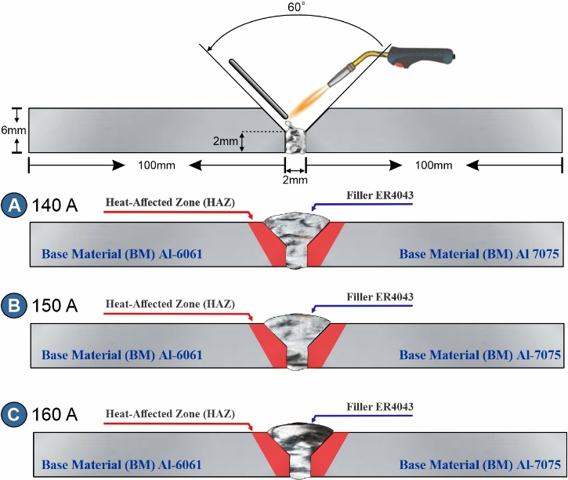
Fig. 2. Schematic drawing of the Al-601 and Al-7075 welded joints using different currents.

Welding parameters
Welding parameters were carefully selected to cover a current range of 140 A, 150 A, and 160 A. These current values were chosen to explore a wider current range to investigate its impact on the mechanical properties and microstructure of the welded material. By combining various current levels, this study aims to create a representative spectrum of welding conditions, thereby facilitating a more comprehensive understanding of the relationship between heat input and the resulting material properties. In addition to current variations, the welding process was performed at an arc voltage of 22 V and a welding speed of 5 cm/min. The gas flow rate is maintained at 10 liters per minute to ensure adequate protection of the welded area. Welding is performed in the 1G position, which is a horizontal position and provides optimal performance for this type of welding. This configuration aims to enhance the overall quality of the welds produced and provide valuable data for analyzing the impact of the selected parameters on the final weld joint.
The selection of welding currents at 140 A, 150 A, and 160 A was based on the recommended operating range for GTAW of 6 mm aluminum plates using a 2.4 mm tungsten electrode. These three current levels represent low, medium, and high heat input conditions within the workable range, enabling a systematic investigation of how heat input variation affects the mechanical properties and microstructure of the dissimilar joint without causing burn-through or insufficient fusion at the extremes.

Microstructure examination
Microstructural examination of weld joints was performed using the procedures specified in ASTM E407. Grinding was carried out using sandpaper to prepare microstructural samples, namely 400, 600, 1000, and 2000 grit, with various degrees of fineness. Further smoothing is then performed using Al₂O₃ paste with a particle size of 0.3 μm to obtain a smoother surface ready for analysis. Microscopic examination of weld joints is conducted using an etching technique with Keller’s reagent, which consists of 3 mL of HF and 100 mL of H₂O. This etching process is essential to reveal the microstructure. Subsequently, the microstructure of various zones, including the Heat-Affected Zone (HAZ) and BM, was observed and photographed using an Integrated Metallographic Microscope (OM). After observation, the images obtained are analyzed using specialized software to gain deeper insights into the microstructural characteristics of the welded joint. This process aims to further understand the properties and quality of the welded joint produced and evaluate the influence of welding conditions on the microstructure of the material.

Mechanical testing
To analyze the mechanical behavior of all weld specimens, tensile properties were tested, including Ultimate Tensile Strength (UTS), Yield Strength (YS), and elongation percentage (El%). Impact testing at room temperature using a universal testing machine (WDW-300D, Guangdong, China) was also conducted. ASTM E8M-04 standards conducted the tensile tests to determine the mechanical behavior of Al-6061 and Al-7075 welded alloys (Fig. 3). Additionally, microhardness profiles were measured on the polished cross-sections using a Vickers hardness tester with a load of 0.5 kg and a dwell time of 15 seconds at all welding locations. By ASTM E384-09 standards, each weld zone was tested with specific samples to measure hardness, thereby providing accurate information on hardness distribution along the weld joint. This process is crucial for understanding how welding conditions influence the mechanical properties and hardness of the material, which in turn can provide insights into the performance of welded joints in real-world applications [35, 36].

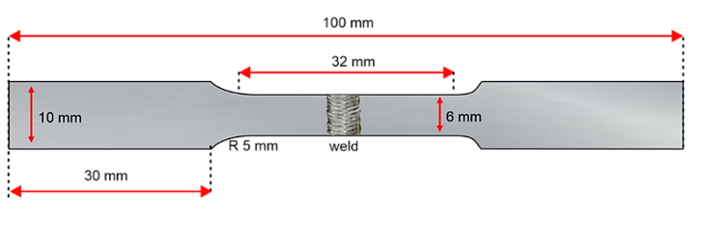
Fig. 3. Dimensions of tensile specimen as per ASTM E8 standard.

Results and discussion
The tests were conducted using three welding current variations: 140 A, 150 A, and 160 A. The test results in Fig. 4 show that the range of currents used produced weld joints free from significant defects such as cracks and porosity. Based on visual observations of the weld specimens produced, no defects were found in the weld shape, either on the surface or at the weld root. This indicates that the use of ER4043 welding wire at the tested welding current variations (140 A, 150 A, and 160 A) does not cause the occurrence or formation of significant welding defects. In other words, the welding parameters can produce high-quality weld joints within the tested current range. The morphology or shape of the weld joints produced at various welding current variations (140 A, 150 A, and 160 A) can be seen in Fig. 4(a)–Fig. 4(c). Additionally, all weld joints produced underwent a thorough visual inspection to ensure the samples were free from defects. This visual inspection aims to ensure no defects are overlooked and to ensure the quality of the weld joints produced.

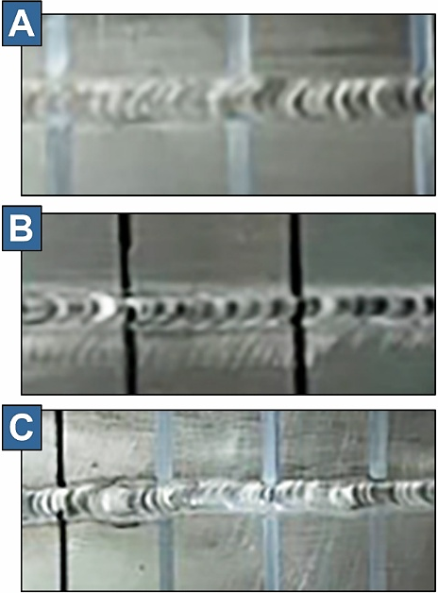
Fig. 4. Surface appearance for welded joints; a) 140A, b) 150A and c) 160A.

Tensile test
Each variation of current strength was replicated three times to test accuracy and reliability, as illustrated in Fig. 5. The current strength variations tested include 140 A, 150 A, and 160 A. Each variation consists of three samples that are coded systematically. It can be shown from Fig. 5, the fractures of the tensile test specimens occurred in the weld area. This indicates that the welding zone is weaker than the base metal and the other regions. This phenomenon can occur due to differences in material composition and microstructure in the welding results between Al-6061 and Al-7075, which cause non-uniformity in strength at the joint. To support further analysis, the complete tensile strength test data are available in Fig. 6. Based on the diagram presented, it is clear that welding with a current strength of Al-6061 produces the highest tensile strength value, reaching 42.83 N/mm². These results show that increasing the current strength has a positive impact on the quality of the welded joints. With greater current strength, the heat energy generated during the welding process becomes more optimal, so that better penetration and fusion between the base metals of Al-6061 and Al-7075 can be achieved. This then contributes to an increase in the mechanical strength of the joint. In contrast, the lowest tensile strength value was obtained at 140 A, only 22.66 N/mm². This low tensile strength is thought to be due to several factors, such as insufficiently deep penetration and the formation of welding defects during the process. Possible defects include lack of fusion, porosity formation due to trapped gas, or even non-uniformity in the joint area. All of these factors can reduce the structural integrity of the joint and increase the risk of failure under load.
The significant difference between the welding results in the three variations of current strength proves that the current strength parameter is one of the main variables that significantly affects the quality of welded joints. In dissimilar welding between Al-6061 and Al-7075, where differences in material characteristics such as melting point and thermal conductivity certainly exist, the selection of the proper current strength becomes even more crucial. A current strength that is too low is not able to produce a strong bond between metals, while a current strength that is too high has the potential to cause distortion or damage to the microstructure. Therefore, these findings have important implications for practical applications in industry, particularly in welding metal alloys for structures that demand high strength. The current strength parameter of 160 A was shown to provide the best results in this study and can be recommended as the primary choice in dissimilar welding between Al-6061 and Al-7075. Thus, the resulting satisfy the strength standards and fulfills the structural feasibility requirements for technical and industrial use.

. 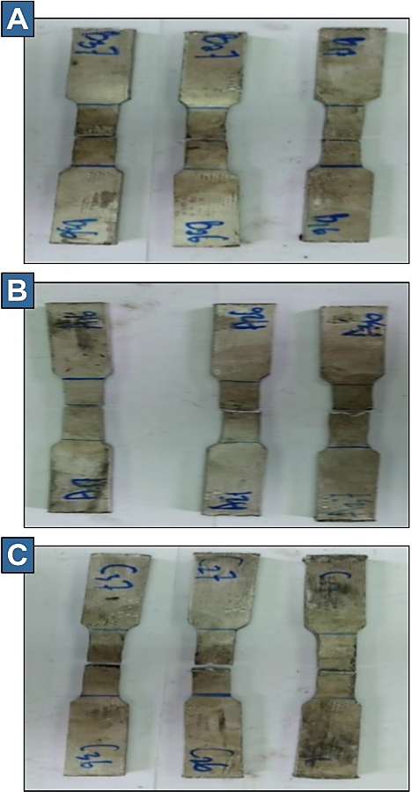
Fig. 5. Tensile test specimen drawing specimen; a) 140A, b) 150A and c) 160A.

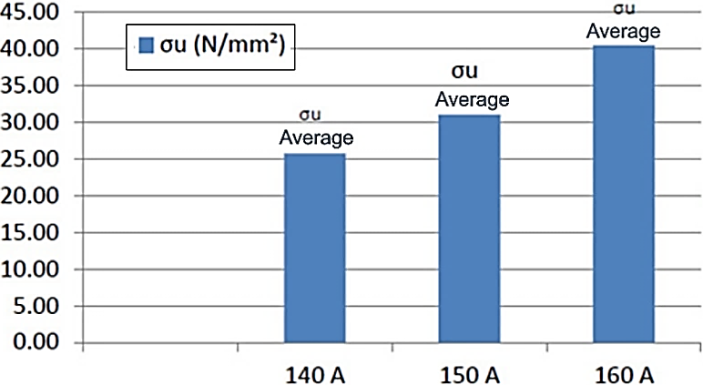
Fig. 6. Graph of the tensile strength of the welded material.

Hardness test
The parameters used in Vickers microhardness testing focus on the variation of current strength applied during the welding process. In this study, three levels of current strength were applied, namely 140 A, 150 A, and 160 A. Each weld produced using the GTAW method was then taken one sample from each current strength to be tested for hardness. It is important to note that the sample must be in a flat condition before the test is carried out. Therefore, the polishing process is carried out first to ensure the surface of the sample is flat so that there is no shift in the position of the sample, which can affect the test results.
Vickers microhardness testing was carried out on five different areas, which included Al-7075 base material, Al-7075 HAZ, weld area, Al-6061 HAZ, and Al-6061 base material. Each region has different material characteristics, so testing at each location is essential to obtain comprehensive data. In each area, tests were conducted at three predetermined points, namely points 1, 2, and 3 in the Al-7075 base material; points 4, 5, and 6 in the Al-7075 HAZ; points 7, 8, and 9 in the weld area; points 10, 11, and 12 in the Al-6061 HAZ; and points 13, 14, and 15 in the Al-6061 base material. In this way, the test can provide a clear picture of the hardness distribution on the various parts of the tested material.
The results of Vickers microhardness testing are significant for understanding the mechanical properties of materials used in engineering applications. The data obtained from the test will provide information on the strength and resistance of the material to deformation. The test results as shown in Fig. 7, which compares the hardness at each test point. An in-depth analysis of this data is expected to provide a better insight into the effect of current strength variation on material hardness and assist in the development and selection of appropriate materials for various engineering applications.
From the results of the hardness tests carried out, it can be concluded that the hardness values resulting from variations in current strength of 140 A, 150 A, and 160 A do not show significant differences. Although there are variations in current strength, the hardness value obtained from the Al-6061 base material and the 6061 HAZ is higher when compared to the Al-7075 base material and Al-7075 HAZ. This shows that the Al-6061 material has better resistance to deformation than the Al-7075 material. The graph presenting the hardness values shows that the highest hardness value is found in the base material, followed by a decrease in hardness value in the HAZ, and the lowest hardness value is found in the weld area. This test recorded the highest hardness value on the Al-6061 base material with a current strength of 160 A, reaching 111.2 VHN. This indicates that welding this material with a higher current strength can produce optimal hardness. However, after reaching the HAZ, the hardness value decreased significantly. On the other hand, the lowest hardness value was recorded in the weld metal for a current strength of 160 A, which only reached 54.7 VHN. This decrease indicates that the welding process can affect the material's microstructure, which affects the final hardness.
Overall, the average analysis shows that welding with a current strength of 150 A results in higher hardness values compared to welding using current strengths of 140 A and 160 A. This may be due to the more stable and optimized welding conditions at a current of 150 A, which allows achieving a better microstructure. Thus, proper selection of current strength is essential to achieve the desired mechanical characteristics in the welded material.
The apparent discrepancy between the highest tensile strength at 160 A and the lower weld zone hardness (54.7 VHN) at this current compared to 140 A and 150 A can be reconciled by recognizing that tensile strength reflects the global load-bearing capacity of the entire joint cross-section, integrating contributions from the base metal, HAZ, and weld zone. In contrast, Vickers hardness is a localized measurement that reflects only the point-specific resistance to indentation. At 160 A, the increased heat input produces better fusion and penetration, enhancing the overall bond quality and load transfer across the joint, while simultaneously promoting grain growth in the weld zone that reduces local hardness. This explains why the 160 A condition achieves the highest tensile strength despite its lower weld zone hardness, consistent with the Hall-Petch relationship where coarser grains reduce local hardness, but the improved joint integrity dominates the overall tensile response.

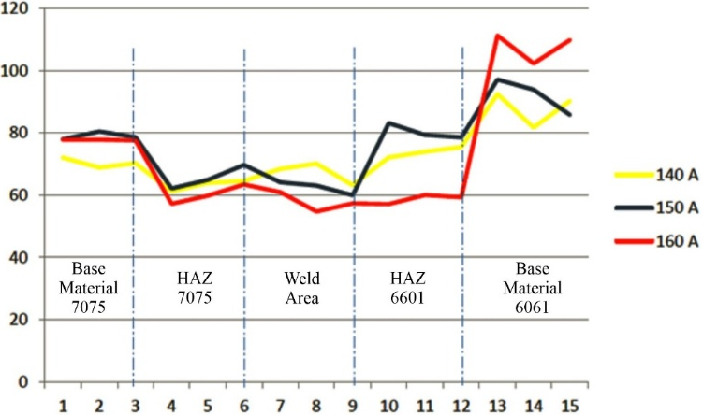
Fig. 7. Hardness value.

Microstructure
According to the result shown in Fig. 8, which illustrates the microstructure of the dissimilar welding results between Al-6061 and Al-7075 under a magnification of 500 times, two primary phases are readily apparent. The first phase is the aluminum solid solution, which is identified by the white color in the image. The second phase is the Mg₂Si compound, which is shown in black. The presence of these two phases is very important in determining the mechanical properties of the weld material. Magnesium (Mg) and silicon (Si) content play a crucial role in influencing the mechanical characteristics of aluminum. When these two elements are at the right temperature during the welding process, they will react to form the Mg₂Si compound. The formation of this compound can increase the strength and hardness of the material, which in turn will affect the performance of the material in various applications.

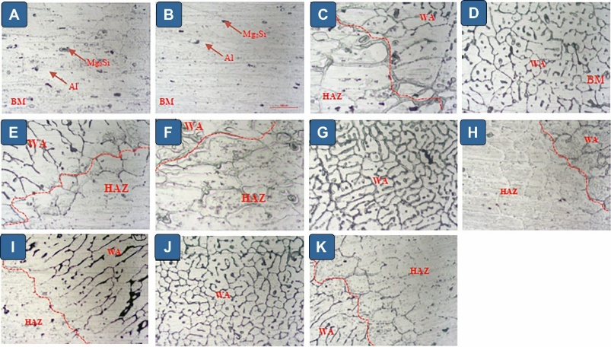
Fig. 8. Microstructure A) BM 6061, B) BM 7075, C) HAZ 6061 140 A, D) WA 140 A, E) HAZ 7075 140 A, F) HAZ 6061 150A, G) WA 150A, H) HAZ 7075 160 A, I) HAZ 6061 160 A, J) WA 160 A, K) HAZ 7075 160 A.

It can be shown from Fig. 8 A and B, the presence of phases like Mg₂Si and Al indicates a microstructure consistent with aluminum containing magnesium and silicon as reinforcing elements. These intermetallic compounds strengthen the alloy and improve its resistance to corrosion, while the aluminum matrix offers structural support. Fig. 8 C and D show the transition from the BM to the welded area (WA). The rapid cooling that occurs during welding often modifies the grain structure, resulting in finer grains within the WA, which can improve the material’s mechanical properties. The HAZ, shown in Fig. 8 E and F, undergoes thermal cycles that alter its microstructure without reaching melting temperatures. This zone is critical because it can develop a combination of hardness and toughness, which may or may not be desirable for the overall performance of the welded joint. The microstructures in Fig. 8 I, J, and K suggest that the welding thermal cycles have produced different heterogeneous grain structures in the HAZ and WA. These differences can significantly impact mechanical characteristics such as fatigue resistance and toughness.
Further analysis revealed that the microstructure in the Al-6061 HAZ contained more Mg₂Si phase than the Al-7075 HAZ. This finding indicates a chemical composition and thermal behavior difference between these aluminum alloys. In addition, this study also found that increasing the welding current strength negatively correlated with the amount of Mg₂Si phase formed. This is due to the increased heat input and slower cooling rate when the current strength increases. These conditions promote grain growth, reducing the amount of Mg₂Si phase that can form in the microstructure. Knowing these microstructural changes is critical not only for determining the functionality of welded parts but also for developing welding processes to enhance the quality and dependability of the joints in engineering applications.
This difference in Mg₂Si phase fraction correlates directly with the chemical compositions of the two base metals. Al-6061 contains approximately 0.63 wt% Mg and 0.42 wt% Si, while Al-7075 contains 2.5 wt% Mg but only 0.4 wt% Si. The formation of Mg₂Si requires both Mg and Si; during welding, Si from the ER4043 filler (which contains 4.5-6.0 wt% Si) diffuses preferentially into the Al-6061 side HAZ where it reacts with the available Mg to form Mg₂Si precipitates. On the Al-7075 side, despite the higher Mg content, the Zn-Cu alloying system in Al-7075 tends to form MgZn₂ (eta phase) precipitates preferentially over Mg₂Si, resulting in a lower Mg₂Si fraction in the Al-7075 HAZ.

Conclusions
Several key conclusions can be drawn based on the comprehensive research results on dissimilar welding between Al-6061 and Al-7075. First, tensile testing showed that the highest tensile strength, reaching 42.83 N/mm² was achieved in specimens welded with a current strength of 160 A. While the lowest tensile strength of 22.66 N/mm² was obtained when welding with a current strength of 140 A. All tensile specimens fractured in the weld zone, indicating that this region was the weakest part of the joint. Secondly, Vickers microhardness testing revealed that the highest hardness value was found in the Al-6061 base metal welded with a current strength of 160 A, reaching 111.2 VHN. The hardness value then decreased in the HAZ, and the lowest value was recorded in the weld metal with a current strength of 160 A, which was 54.7 HVN. Welding with a current strength of 150 A showed higher average hardness values than welding using current strengths of 140 A and 160 A. Thirdly, microstructural observations at 500× magnification revealed the presence of two dominant phases which were the aluminum solid solution and the Mg₂Si compound, which strongly influenced the weld properties. Although increasing the welding current to 160 A improved tensile strength, excessive heat reduced hardness and affected microstructural stability. Therefore, 150 A is considered the optimum welding current, providing a better balance of tensile performance, hardness distribution, and microstructural integrity for structural applications.

Acknowledgments
The author expresses gratitude for the financial assistance from the Indonesia Endowment Fund for Education (LPDP) and the Directorate General of Vocational Education, Ministry of Education, Culture, Research, and Technology of the Republic of Indonesia, under contract number 3227/D6/DV.03.00/2024 and DIPA fund of Politeknik Negeri Medan for the year 2024, under contract number B/159/PL5/PT.01.05/2024.

References
[1] Wu Y. Application of aluminum alloy in aircraft. Journal of Physics: Conference Series. 2022;2228(1):012024.
[2] Li SS, Yue X, Li QY, Peng HL, Dong BX, Liu TS, et al. Development and applications of aluminum alloys for aerospace industry. Journal of Materials Research and Technology. 2023;27:944-83.
[3] Singh VP, Patel SK, Ranjan A, Kuriachen B. Recent research progress in solid state friction-stir welding of aluminium–magnesium alloys: a critical review. Journal of Materials Research and Technology. 2020;9(3):6217-56.
[4] Goriparthi V, Nallu R, Chebolu R, Indupuri S, Rudrapati R. Experimental Studies on Mechanical Behavior of TIG and Friction Stir Welded AA5083 -AA7075 Dissimilar Aluminum Alloys. 2023;2023(1):8622525.
[5] Soltan H, Omar M. A roadmap for selection of metal welding process: a review and proposals. Welding in the World. 2022;66(12):2639-75.
[6] Khalafe WH, Sheng EL, Bin Isa MR, Omran AB, Shamsudin SB. The Effect of Friction Stir Welding Parameters on the Weldability of Aluminum Alloys with Similar and Dissimilar Metals: Review. 2022;12(12):2099.
[7] Rambabu P, Prasad N, Kutumbarao V, Wanhill R. Aluminium Alloys for Aerospace Applications. 2017. p. 29-52.
[8] Zhu H, Li J. Advancements in corrosion protection for aerospace aluminum alloys through surface treatment. International Journal of Electrochemical Science. 2024;19(2):100487.
[9] Feddal I, Chairi M, Di Bella G. Analysis of Friction Stir Welding of Aluminum Alloys. Metals2025.
[10] Selly Septianissa WNiH, Ayu Zahra Chandrasari. Mechanical and microstructural effects of varying welding currents in GTAW of 7075-T62 aluminum. Polimesin. 2025;23:32 - 7.
[11] Soundararajan R, Ramkumar KR, Sivasankaran S, Kim HS. Enhancement of tensile strength in AA 6061-T6 plates joined by gas tungsten arc welding using high entropy alloy filler sheet. Materials Science and Engineering: A. 2022;832:142481.
[12] Malik Q. Gas tungsten Arc Welding (GTAW) or (TIG) Welding. 2021.
[13] Zhu R, Ji X, Yuan B, Liang Z, Du P, Zhang L, et al. Microstructure and mechanical properties of 7075 aluminum alloy welds by gas tungsten arc welding with trailing ultrasonic rotating extrusion. Journal of Materials Research and Technology. 2024;33:1446-59.
[14] Sohel M, Sharma VS, Arumugam A. Engineering Perfection in GTAW Welding: Taguchi-Optimized Root Height Reduction for SS316L Pipe Joints. 2025;9(6):188.
[15] Di Bella G, Favaloro F, Borsellino C. Effect of Process Parameters on Friction Stir Welded Joints between Dissimilar Aluminum Alloys: A Review. 2023;13(7):1176.
[16] Slobodyan M. Arc welding of zirconium and its alloys: A review2021.
[17] Su S, Chen S, Mao Y, Xiao J, Vivek A, Daehn G. Joining Aluminium Alloy 5A06 to Stainless Steel 321 by Vaporizing Foil Actuators Welding with an Interlayer. 2019;9(1):43.
[18] Karakas Ö, Kardeş F, Foti P, Berto F. Dissimilar Welding Applications and Evaluation of Fatigue Behaviour of Welded Jo ints: An Overview. Strength of Materials. 2023;55:111-27.
[19] Mehta KP. A review on friction-based joining of dissimilar aluminum–steel joints. Journal of Materials Research. 2019;34(1):78-96.
[20] Dubey D, Mirhakimi AS, Elbestawi MA. Negative Thermal Expansion Metamaterials: A Review of Design, Fabrication, and Applications. 2024;8(1):40.
[21] Dada M, Popoola P. Recent advances in joining technologies of aluminum alloys: a review. Discover Materials. 2024;4(1):86.
[22] Azwinur Azwinur MHK, Usman Usman, Surya Dharma. The effect of TIG welding technology parameters on the weld quality of copper material joints for heat pipe applications. Polimesin. 2024;22:666 - 71.
[23] Çevik B. Gas tungsten arc welding of 7075 aluminum alloy: Microstructure properties, impact strength, and weld defects. Materials Research Express. 2018;5.
[24] Kotari S, Punna E, Reddy SMG, Venukumar S. Experimental Investigation and Micro Structural Characteristics of GTAW and FSW Welded Dissimilar Aluminum Alloys. IOP Conference Series: Materials Science and Engineering. 2020;998(1):012036.
[25] Bansal A, Senthil Kumar M, Shekhar I, Chauhan S, Bhardwaj S. Effect of welding parameter on mechanical properties of TIG welded AA6061. Materials Today: Proceedings. 2021;37:2126-31.
[26] Fouad RA, Habba MIA, Elshaghoul YGY, El-Sayed Seleman MM, Hafez KM, Hamid FS, et al. The influence of various welding wires on microstructure, and mechanical characteristics of AA7075 Al-alloy welded by TIG process. Scientific Reports. 2024;14(1):19023.
[27] Prasanna Nagasai B, Anusha CH, Rajesh A. Study on mechanical properties of Al-6061/ZrO2 reinforced metal matrix composites. Materials Today: Proceedings. 2021;47:4552-7.
[28] Imran M, Khan ARA. Characterization of Al-7075 metal matrix composites: a review. Journal of Materials Research and Technology. 2019;8(3):3347-56.
[29] Karpagaraj A, Edberk JAS, Kannan TDB, Rajendran DK, Ramesh T. Effect of GTAW process parameters on joining stainless steel 316L. AIP Conference Proceedings. 2022;2460(1).
[30] Kumar S, Madugula NS, kumar R, Kumar N, Giri J, kanan M. An extensive analysis of GTAW process and its influence on the microstructure and mechanical properties of SDSS 2507. Journal of Materials Research and Technology. 2024;33:8675-86.
[31] Ghumman KZ, Ali S, Din EU, Mubashar A, Khan NB, Ahmed SW. Experimental investigation of effect of welding parameters on surface roughness, micro-hardness and tensile strength of AISI 316L stainless steel welded joints using 308L filler material by TIG welding. Journal of Materials Research and Technology. 2022;21:220-36.
[32] Afzal MS, Wakeel A, Nasir MA, Qazi MI, Abas M. Optimization of process parameters for shielded metal arc welding for ASTM A 572 grade 50. Journal of Engineering Research. 2024.
[33] Ahmed M, Javidani M, Maltais A, Chen XG. Comparison of Mechanical, Fatigue, and Corrosion Properties of Fusion-Welded High-Strength AA6011 Alloy Using Three Filler Wires. Processes2024.
[34] Singh IJ, Murtaza Q, Kumar P. Multi-Response Optimization of Process Parameters for Cold Metal Transfer Welded Joints of Dissimilar Alloys AA8011 and AA6061. Journal of Materials Engineering and Performance. 2025.
[35] Shao Q, Shi Y, Wang X, Li M, Chang Y, Gan Y, et al. Study of repair welding on microstructure, mechanical properties and corrosion resistance of dissimilar welded joints of SUS304 and Q345B steel. Journal of Materials Research and Technology. 2023;23:4173-89.
[36] Tagimalek H, Maraki MR, Mahmoodi M, Moghaddam HK, Farzad-Rik S. Prediction of mechanical properties and hardness of friction stir welding of Al 5083/pure Cu using ANN, ICA and PSO model. SN Applied Sciences. 2022;4(4):102.

