 |  | Jurnal Polimesin
 |  | Department of Mechanical Engineering
 |  | State Polytechnic of Lhokseumawe
 |  | http://e-jurnal.pnl.ac.id/polimesin
e-ISSN | : 2549-1999 |  | No. | : 1 | Month | : February
p-ISSN | : 1693-5462 |  | Volume | : 24 | Year | : 2026
Processing dates: received on 2025-12-4, reviewed on 2026-01-06, accepted on 2026-01-29 and online availability on 2026-02-28
Multi-objective tribological and energy optimization of an automatic valve lapping machine using a hybrid RSM NSGA-II approach
Reinaldi Teguh Setyawan^{1,*}, Ery Muthoriq², Syahrizal¹
¹Department Mechanical Engineering, Politeknik Negeri Bengkalis, Bengkalis 28711, Indonesia
²Department Automotive Engineering, Politeknik Keselamatan transportasi Jalan, Tegal 52111, Indonesia
*Corresponding author: reinaldi@polbeng.ac.id
Abstract
Optimizing valve seat reconditioning requires balancing sealing performance, surface integrity, energy consumption, and component wear within practical workshop constraints. This study presents the design, development, and multi-objective optimisation of a low-cost automatic valve lapping system using a hybrid Response Surface Methodology (RSM) and Non-dominated Sorting Genetic Algorithm II (NSGA-II) framework. A prototype automatic valve lapping rig was developed by integrating a DC-motor-driven spindle with adjustable spring loading and an Arduino-based control and data-acquisition system, enabling controlled variation of spindle speed (300–600 rpm) and axial load (60–140 N). Leakage time, surface roughness (Ra), electrical energy consumption, and valve wear volume were measured using a three-level factorial design. Quadratic response surface models with satisfactory statistical adequacy were established for all responses. The RSM models were employed in NSGA-II to maximise leakage time and minimise surface roughness, energy consumption, and wear, subject to practical operational constraints. The optimisation results reveal clear trade-offs between sealing quality, energy efficiency, and component life, and identify an optimal operating window of approximately 430–470 rpm and 90–110 N, providing a robust compromise solution and a practical operating map for workshop valve seat reconditioning.
Keywords:
Automatic valve lapping, Arduino, multi-objective optimisation, NSGA-II, response surface methodology, valve seat re-conditioning.

Introduction
Engine poppet valves and their seats operate under severe thermomechanical and tribological loading, so any degradation of the sealing interface directly reduces compression, increases blow-by and emissions, and accelerates component failure [1] [2]. During cylinder head overhaul, grinding and lapping of the valve–seat pair constitute a routine yet critical operation to restore geometric conformity and surface integrity of the sealing band. In most small workshops and educational laboratories, however, valve lapping is still carried out manually using simple hand tools and abrasive paste. As a result, the process outcome is highly dependent on operator skill, time-consuming, and difficult to reproduce or quantify consistently [3], [4].
To reduce manual effort and improve consistency, several authors have proposed dedicated valve lapping or valve cleaning machines in which the rotary reciprocating motion of the valve is provided by cams, followers, or geared drives rather than by hand [5]. These systems demonstrate improved productivity and reduced labour compared to manual lapping. Nevertheless, they are generally designed as production-oriented or garage tools. They are rarely equipped with sensors or data-acquisition capabilities that enable quantitative characterization of key process responses such as surface roughness, sealing performance, energy consumption, wear, vibration, or spindle run-out. Commercial portable valve-lapping systems are also available, but they are relatively expensive and designed for heavy-duty or industrial sealing applications, making them less accessible to small-engine workshops and teaching laboratories.
From a tribological standpoint, valve lapping can be viewed as a low-speed sliding contact between the valve face and the seat under a controlled normal load [6] [7]. The combined effects of spindle speed, axial load, and lapping duration influence the contact pressure, sliding distance, local temperature, and removal rate, which in turn govern surface roughness, wear volume, and sealing capability. Previous work on flat-surface lapping and related finishing operations has shown that carefully designed experiments and statistical modelling can capture the influence of lapping pressure, speed, abrasive size, and slurry conditions on material removal and surface topography, and can even support intelligent advisory systems for process set-up [8]. Parameter optimisation in lapping has also been shown to improve surface finish and control material removal while satisfying practical constraints related to load and cycle time [9], [10].
In parallel, a large body of work in machining and sustainable manufacturing has established Response Surface Methodology (RSM) as a powerful tool for modeling the relationships between controllable parameters and multiple performance metrics. For turning, milling, and grinding, RSM-based quadratic models have been used to quantify how cutting speed, feed rate, and depth of cut affect surface roughness, cutting forces, power consumption, and productivity [11] [12]. More recent contributions explicitly embed energy consumption and environmental indicators alongside conventional quality metrics, and apply multi-objective optimization to balance surface quality, machining cost, noise, and energy use [13] [14] [15]. These studies underline the importance of simultaneously considering quality, tribological behaviour, and energy efficiency rather than addressing them in isolation.
However, RSM on its own tends to yield single-objective or weighted-sum formulations that cannot fully represent the inherent trade-offs between tribological and energy-related responses. In machining science, this limitation is often addressed by coupling surrogate models with evolutionary multi-objective algorithms, particularly the Non-dominated Sorting Genetic Algorithm II (NSGA-II), to obtain Pareto-optimal sets of process parameters [16]. Recent studies have hybridised machine learning or RSM with NSGA-II to minimise surface roughness and cutting forces simultaneously, or to balance roughness, material removal rate, and tool wear under realistic process constraints [17]. These hybrid frameworks are well-suited to explore complex trade-offs such as high sealing quality vs. low energy consumption vs. limited wear in manufacturing and finishing processes.
Although prior lapping studies have established that parameters such as lap speed and applied load strongly influence material removal mechanisms and surface texture [22], [23], and that sealing performance in metal-to-metal interfaces is highly sensitive to surface roughness and contact characteristics [31], [32], directly comparable experimental investigations that focus on engine valve-seat reconditioning and that quantitatively map the combined trade-offs among sealing quality, seat roughness, energy consumption, and wear remain limited in the open literature. In particular, there is a lack of affordable, instrumented lapping systems capable of generating such data under controlled and workshop-relevant conditions. This gap motivates the present study, which positions valve lapping not only as a reconditioning operation but also as a measurable and optimisable tribological process. Accordingly, the present work develops and experimentally evaluates an Arduino-based automatic valve lapping machine as a low-cost re-conditioning solution and as a research and teaching platform. The study integrates controllable spindle speed and axial load with measurement of sealing performance, surface quality, energy consumption, and wear, and applies a combined DOE–RSM–NSGA-II framework to derive a practical operating map that supports informed parameter selection in workshop valve-seat reconditioning. Previous studies on surface finishing and lapping processes have demonstrated that tribological performance, surface integrity, and energy consumption are strongly influenced by the interactions among operating parameters and contact conditions. RSM has been widely applied to establish empirical relationships between process variables and performance indicators in manufacturing and finishing operations, particularly for surface roughness, wear, and energy-related responses. In parallel, multi-objective evolutionary algorithms such as NSGA-II have proven effective for resolving conflicts in machining and finishing process optimisation. These established approaches provide a solid scientific basis for systematic optimisation of tribological processes. Related experimental and optimisation-based studies have also been reported in Jurnal Polimesin, particularly in the areas of machinery development, experimental instrumentation, and process parameter optimisation, which supports the relevance of the present study to the journal's scope.

Method

Automatic valve lapping machine
An automatic valve lapping machine was designed and built as a laboratory-scale platform for engine valve seat reconditioning and process optimisation. The rig consists of a welded steel frame that supports a sliding carriage carrying the spindle unit and loading mechanism, while an automotive cylinder head is clamped on a fixed fixture at the base. A photograph of the developed rig is shown in Fig. 1, illustrating the overall mechanical construction and component layout.

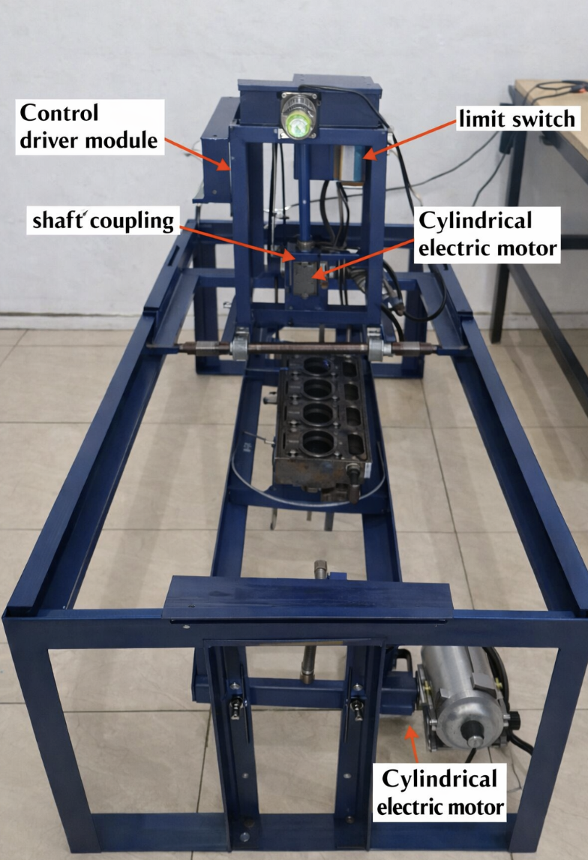
Fig. 1. Automatic valve lapping machine developed in this study.

The rig consists of a welded steel frame supporting a sliding carriage that carries the spindle unit and axial loading mechanism. At the same time, an automotive cylinder head is clamped on a fixed fixture at the base. The spindle nose is equipped with a replaceable adapter that holds the valve stem and maintains concentricity with the seat. Axial load is applied via a calibrated compression spring, which is adjusted using a lead-screw arrangement. Radial run-out of the spindle–valve assembly was checked prior to each test series using a dial indicator and maintained below 0.02 mm.
To provide a clear overview of the experimental workflow and data-analysis procedure adopted in this study, the methodology is summarised in the form of a flow diagram, as shown in Fig. 2. As illustrated in Fig. 2, the experimental methodology begins with specimen preparation, including cleaning, weighing, and mounting of the valve and cylinder head to ensure repeatable initial conditions. The process parameters, namely spindle speed and axial load, are then set according to the predefined experimental design.

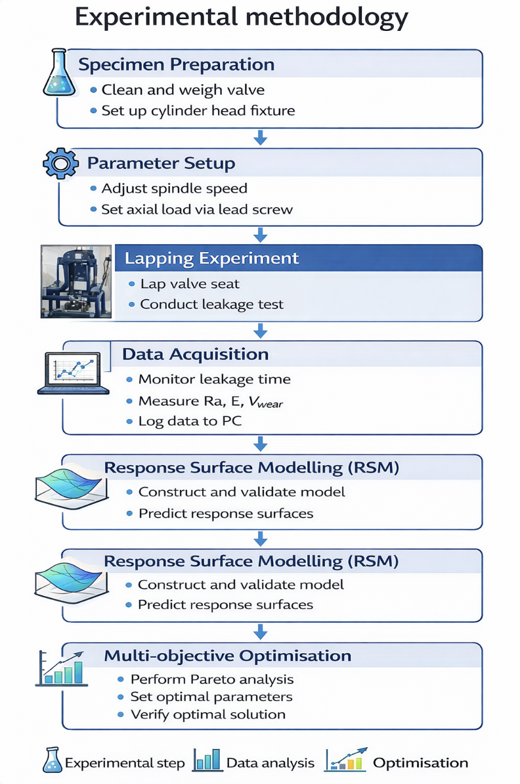
Fig. 2. Flow diagram of the experimental methodology adopted in this study.

The lapping experiment is subsequently carried out under controlled conditions, during which leakage testing is performed, and the relevant process responses are measured. These responses include leakage time, surface roughness, electrical energy consumption, and wear volume. All signals are acquired and logged through the Arduino-based data-acquisition system.
The collected experimental data are then used to construct and validate quadratic response surface models for each response variable. Finally, the validated RSM models are coupled with a multi-objective optimisation procedure to analyse trade-offs among sealing performance, surface integrity, energy efficiency, and wear, thereby identifying Pareto-optimal operating conditions.
The Arduino-based measurement, control, and data-logging chain (load cell–HX711–Arduino–PC, tachometer/limit-switch inputs, and PWM output to the motor driver) is summarised in Fig. 3.

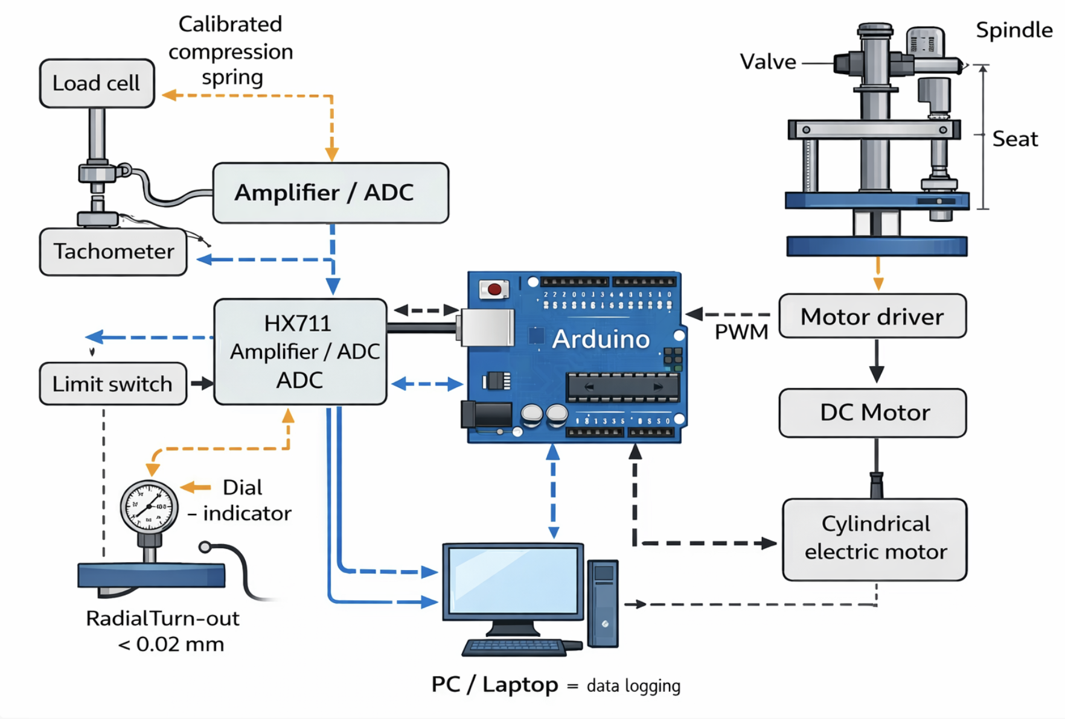
Fig. 3. Block diagram of the Arduino-based measurement, control, and data-logging chain for the valve lapping rig.

The Arduino microcontroller functions as the central control and data-acquisition unit of the system. Axial force is measured using a load cell whose signal is conditioned by an HX711 amplifier/ADC, while spindle speed is monitored using a tachometer. All sensor signals are time-stamped and transmitted to a PC via serial communication for data logging. In addition, the Arduino generates a PWM command to the motor driver, enabling closed-loop regulation of the spindle speed during the lapping process.

Mechanical specifications
The spindle is driven by a 24 V cylindrical brushed DC motor (250 W class) with a nominal torque of 0.80 N·m, estimated from the rated power (250 W) and rated speed (3000 rpm). A precision spindle-to-valve adapter was manufactured with a dimensional tolerance of ±0.02 mm. The assembled spindle–valve radial run-out was verified prior to testing using a dial indicator and maintained below 0.02 mm for all experiments. Axial load was applied through a calibrated compression spring with a stiffness of k=8.0N/mm, determined from a static compression test based on the linear slope of the load–deflection curve over the operating range.

Instrumentation, sampling, and calibration
Axial force was measured using an S-type load cell (50 kg class, capacity 500 N) conditioned by an HX711 amplifier/ADC and interfaced with an Arduino Uno. Prior to testing, the load cell was calibrated using dead weights over the range 0–200 N. A linear calibration relationship was obtained to convert the digital output to force, yielding a coefficient of determination (R²) of 0.999 and a maximum deviation of ±1.5 N.
Spindle speed was monitored using a handheld digital laser tachometer. Tachometer readings were sampled at 10 Hz, and the spindle speed was calculated as a moving average over a 1 s window. For each lapping run, the reported spindle speed corresponds to the mean rpm measured over the entire lapping interval.
The key hardware specifications and measurement settings used in this study are summarised in Table 1. Table 1 presents the key hardware specifications and instrumentation settings of the automatic valve lapping rig used in this study. The listed components define the means by which spindle motion, axial loading, sensing, and data acquisition were implemented, thereby characterising the experimental platform on which all measurements were conducted. The specifications provide the technical context for the measurement procedures. The measurement procedures for the four main responses: leakage time, surface roughness, electrical energy consumption, and wear volume.
The spindle nose is equipped with a replaceable adaptor that holds the valve stem and allows the valve to rotate freely while maintaining concentricity with the seat. Axial load is applied to the valve face by a calibrated compression spring acting through a lever and guide arrangement. The effective load can be adjusted by changing the spring pre-compression using a threaded mechanism. During the experimental campaign, the axial load settings were verified using a load cell and kept within the levels specified in Table 1. The experimental control factors and their corresponding levels used in the study are summarised in Table 2.

Table 1. Key hardware specifications and instrumentation settings
Item | Specification
DC motor | Model: 24 V cylindrical brushed DC motor (250 W class); rated power: 250 W; rated speed: 3000 rpm; nominal torque: 0.80 N·m
Spindle adapter | Material: mild steel (machined); tolerance/run-out: ±0.02 mm; measured assembly run-out: <0.02 mm
Spring loading | Spring type: compression spring (steel); preload: adjustable (lead-screw mechanism); k = 8.0 N/mm (method: static compression test)
Load cell | Model: S-type load cell (50 kg class); capacity: 500 N; signal conditioning: HX711; calibration: dead weights, range 0–200 N, R² = 0.999, max error ±1.5 N
Tachometer/RPM sensor | Model: handheld digital laser tachometer; type: optical; sampling: 10 Hz; RPM method: moving average (1 s window), reporting: mean over lapping interval
Data logging | Arduino Uno → PC via serial; sampling/logging: 10 Hz; time-stamping: yes

Table 2. Experimental factors and levels
Factor | Symbol | Low level | Center level | High level | Unit
Spindle speed | x₁ | 300 | 450 | 600 | rpm
Axial load | x₂ | 60 | 100 | 140 | N

Table 2 lists the experimental control factors and their corresponding levels adopted in the response surface methodology. The selected ranges for spindle speed and axial load define the design space over which the lapping process was systematically investigated. These factor levels form the basis for the experimental design, data acquisition, and subsequent modelling of the process responses.
An Arduino Uno microcontroller was used as the core of the control and data-acquisition system. The board generates the PWM signal for the motor driver and simultaneously reads sensor signals. Spindle speed was monitored with an optical tachometer during calibration and periodically checked during the tests. The electrical current drawn by the motor was measured with a Hall-effect current sensor, which, together with the known supply voltage, enabled the computation of instantaneous electrical power and energy consumption for each lapping run. Additional instrumentation included a thermocouple placed near the valve-seat region to monitor local temperature and a dial indicator to measure radial run-out of the spindle–valve assembly before each series of experiments. Run-out was maintained below 0.02 mm for all tests.

Measurement of tribological and energy responses
The measurement procedures for the four main responses: leakage time, surface roughness, electrical energy consumption, and wear volume. These responses were selected to characterise the tribological and energy behaviour of the lapping process.

Leakage time ($y_{1}$)
Sealing performance of the valve–seat pair was assessed using a simple leakage test. After each lapping operation, the combustion chamber corresponding to the tested valve was filled with a reference test fluid up to a marked level. The time required for the fluid level to drop to a prescribed lower mark, due to leakage across the valve–seat interface, was measured with a stopwatch and recorded as the leakage time $t_{leak }$(s). Larger values of $t_{leak}$indicate better sealing capability.

Surface roughness ($y_{2}$)
The surface roughness of the lapped seat band was measured using a portable roughness tester. Measurements were taken along the circumferential direction at three evenly spaced positions and averaged to obtain the arithmetic mean roughness Ra (µm). Lower Ra values are desirable from the viewpoint of sealing and surface integrity.

Energy consumption ($y_{3}$)
Electrical energy consumption per lapping operation was obtained from the measured current and known supply voltage. For each run, the average current $I$over the lapping time $t$ was used to estimate the electrical power $P=VI$, and the energy was computed as $E=\frac{VIt}{3600},$expressed in watt-hours (Wh). Lower values of $E$ correspond to more energy-efficient operation.

Wear volume ($y_{4}$)
Valve wear volume was estimated from the change in valve mass before and after lapping. Each valve was cleaned, dried, and weighed with a precision balance to obtain the initial mass. After lapping and leakage testing, the valve was cleaned again and re-weighed. Assuming uniform material removal from the valve face, the mass loss was converted to volume using the nominal material density, yielding the wear volume $V_{wear}$ in mm³. Lower wear volume is preferred in order to extend component life and preserve geometry.
In addition to these four primary responses, several auxiliary quantities were monitored to ensure safe and repeatable operation. The RMS vibration level of the frame was measured with a small accelerometer mounted near the spindle support, and the maximum temperature near the seat region was recorded from the thermocouple. Across all experiments, RMS vibration remained in the range of approximately 1.2–2.0 m/s² and the local temperature did not exceed 40°C. These ranges were later used as practical constraints in the optimisation stage.
Each experimental condition was repeated three times using fresh valves and lapping compound; the reported response values in Table 2 correspond to the arithmetic averages of the three repetitions. The experimental design matrix and the corresponding measured responses for each test run are summarised in Table 3.
Table 3 presents the experimental design matrix together with the corresponding measured responses for each test run. The table links selected combinations of spindle speed and axial load to the resulting leakage time, surface roughness, energy consumption, and wear volume, thereby providing the complete dataset for response surface modelling and subsequent multi-objective optimisation. The reported values represent the averaged results of repeated experiments conducted under identical conditions.

Table 3. Design matrix and measured responses
Run | Spindle speed  (rpm) | Axial load  (N) | Leakage time  ($t_{leak}$) (s) | Surface roughness  Ra (µm) | Energy  E (Wh) | Wear volume  ($v_{wear}$) (mm³)
1 | 300 | 60 | 22 | 1.2 | 2.52 | 0.60
2 | 300 | 100 | 27 | 1.0 | 2.38 | 0.80
3 | 300 | 140 | 23 | 1.2 | 2.22 | 1.00
4 | 450 | 60 | 27 | 1.0 | 2.34 | 0.90
5 | 450 | 100 | 32 | 0.8 | 2.17 | 1.10
6 | 450 | 140 | 25 | 1.0 | 1.97 | 1.30
7 | 600 | 60 | 23 | 1.2 | 2.10 | 1.00
8 | 600 | 100 | 25 | 1.0 | 1.89 | 1.30
9 | 600 | 140 | 23 | 1.4 | 1.66 | 1.60

Design of experiments
Based on these specifications, the experiments were conducted by varying spindle speed and axial load according to the factor levels listed in Table 2. For each experimental condition, the rig was stabilised to the target speed and load prior to lapping, and the corresponding sensor signals were logged over the lapping interval. Table 3 lists the treatment combinations, and the reported responses correspond to the arithmetic mean of three repetitions. Two process parameters were chosen as controllable factors: spindle speed and axial load. Their levels were selected based on preliminary trials to cover the range typically used in workshop practice while avoiding chatter, overheating, or excessive wear: (1) spindle speed $x_{1}$: 300, 450, and 600 rpm; (2) axial load $x_{2}$: 60, 100, and 140 N.
The factor levels, summarised in Table 1, were coded to dimensionless variables $x_{1}$and $x_{2}$using the standard linear transformation (Eq. (1)), where $X_{i}$is the actual value, $X_{i}$is the centre level and $ΔX_{i}$ is half of the range for factor $i$. This coding maps the low, centre, and high levels to –1, 0, and +1, respectively.
$x_{i}=\frac{X_{i}-X_{i,center}}{ΔX_{i}}$ (1)

A full three-level factorial design (3², nine treatment combinations) was selected because only two controllable factors were investigated, and a second-order RSM model was required. For two factors, the 3² factorial provides sufficient information to estimate linear, quadratic, and interaction terms while uniformly covering the entire feasible operating window defined by the speed and load limits. In contrast, a Central Composite Design (CCD) would introduce axial (star) points that may fall outside the practical constraints of the rig, and Box–Behnken designs are primarily intended for three or more factors. Each of the nine combinations was repeated three times (27 trials total) to quantify pure experimental error and improve the precision of the fitted models. The run order of all trials was fully randomised using a random number generator, and no formal blocking was applied.
A full three-level factorial design with $3^{2}=9$ runs were adopted. The resulting design matrix, along with the measured responses $y_{1}$–$y_{4}$, is presented in Table 2. The order of the experiments was randomised to minimise the influence of uncontrolled drift in machine or environmental conditions. Between runs, the lapping compound was renewed and the seating surfaces were cleaned to reduce cross-contamination.

Response surface modelling
RSM was employed to develop empirical models relating the coded process parameters $x_{1}$and $x_{2}$ to each response $y_{j}$($j=1,…,4$) following standard procedures for RSM-based process optimisation in manufacturing (Montgomery, 2017). For each response, a second-order polynomial of the form Eq. (2), where $β_{kj}$are regression coefficients and $ε_{j}$ is the random error term.

$y_{j}=β_{0j}+β_{1j}x_{1}+β_{2j}x_{2}+β_{12j}x_{1}x_{2}+β_{11j}x_{1}^{2}+β_{22j}x_{2}^{2}+ε_{j}$ (2)

The coefficients were estimated by least-squares using the experimental data from Table 2. Statistical Analysis of Variance (ANOVA) was performed for each model to evaluate the significance of individual terms and the overall Adequacy of the regression [20] [21] [22]. The coefficient of determination $R^{2}$, adjusted $R^{2}$, and p-values associated with F-tests were used as primary indicators of fit quality. If necessary, non-significant terms were removed through a stepwise regression procedure while maintaining model hierarchy, and the reduced models were re-evaluated.
The final models were then used to generate contour and response-surface plots in the $\left(x_{2}\right)$ space for each response, providing visual insight into how spindle speed and axial load influence leakage time, surface roughness, energy consumption, and wear volume.

Multi-objective optimisation using NSGA-II
The validated response surface models served as surrogate functions in a multi-objective optimisation framework based on the NSGA-II. The decision variables were the coded process parameters $x_{1}$ and $x_{2}$, constrained within the design space $\left[-1,+1\right]$. Four objective functions were formulated directly from the RSM models: (1) maximise $f_{1}(x_{1},x_{2})=y_{1}(x_{1},x_{2})$ (leakage time); (2) minimise $f_{2}(x_{1},x_{2})=y_{2}(x_{1},x_{2})$ (surface roughness Ra); (3) minimise $f_{3}(x_{1},x_{2})=y_{3}(x_{1},x_{2})$ (energy consumption); (4) minimise $f_{4}(x_{1},x_{2})=y_{4}(x_{1},x_{2})$ (wear volume).
In addition to the bounds on $x_{1}$and $x_{2}$, the practical constraints were imposed to ensure acceptable dynamic and thermal behaviour of the machine: radial run-out of the spindle valve assembly ≤ 0.02 mm, RMS vibration level within the experimentally observed range (approximately 1.2–2.0 m/s²), and maximum local temperature near the valve seat $T_{max}≤{40}^{∘}$C.
NSGA-II was implemented using a real-coded representation of the decision variables. A typical configuration was used, with a population size of 80–100 individuals, a crossover probability of 0.9 for simulated binary crossover, and a mutation probability of 0.1 for polynomial mutation, in line with common practice in multi-objective optimisation studies [23]. The algorithm was run for a sufficient number of generations (e.g., 150–200) to achieve convergence of the Pareto front. Because the objective function evaluations rely on inexpensive analytical RSM models rather than direct experiments, the computational cost of the optimisation was negligible compared with the experimental effort.
The final Pareto front provides a family of non-dominated solutions that represent different trade-offs among sealing performance, surface integrity, energy use, and wear. From this set, a few representative operating points were selected for detailed discussion in the Results and Discussion section: a solution emphasising maximum leakage time, a solution prioritising minimum energy consumption and wear, and a balanced compromise solution suitable for general workshop practice.

Results and discussion

Adequacy of the response surface models
Fig. 4 compares the experimental measurements with the corresponding responses predicted by the developed RSM models for (a) leakage time, (b) surface roughness, (c) energy consumption, and (d) wear volume. In all cases, the data points are closely distributed around the 45° reference line, indicating a strong agreement between predicted and experimental values. This result confirms that the second-order RSM models accurately capture the relationships among spindle speed, axial load, and the four performance responses over the investigated parameter range.

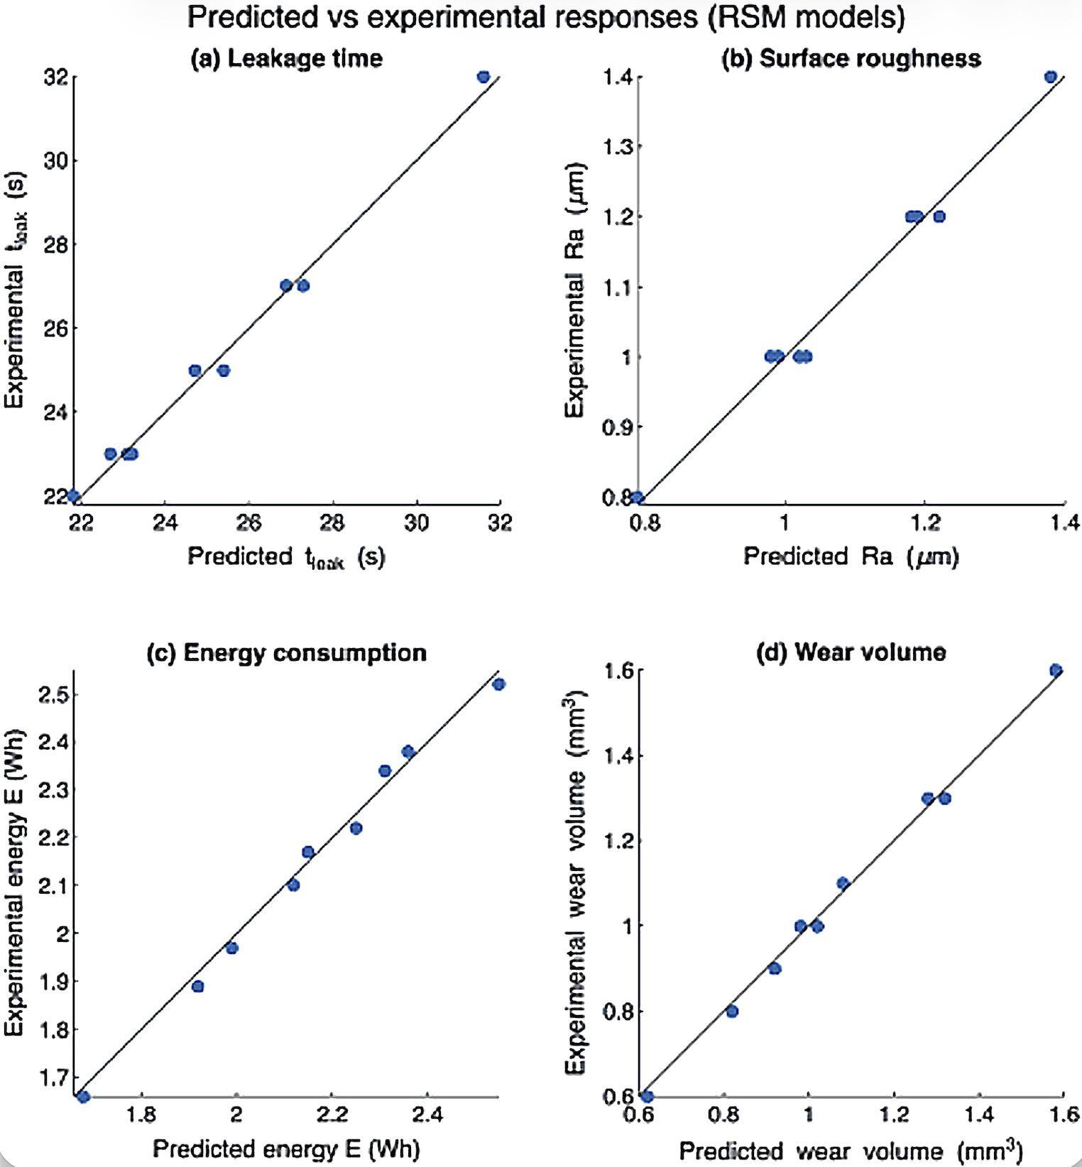
Fig. 4. Predicted vs experimental responses (RSM models) (a) leakage time, (b) surface roughness, (c) energy consumption, (d) wear volume.

The predictive performance of the models for leakage time and surface roughness demonstrates their suitability for representing sealing-related tribological behaviour. At the same time, the similarly strong agreement for energy consumption and wear volume indicates that the models reliably describe efficiency and durability-related responses. Consequently, the validated RSM models provide a robust foundation for the subsequent multi-objective optimisation and Pareto analysis.
Second-order RSM models were successfully fitted for all four responses: leakage time ($y_{1}$), surface roughness ($y_{2}$), energy consumption ($y_{3}$) and wear volume ($y_{4}$). The ANOVA results (summarised in Table 3) indicate that the quadratic models are statistically significant at the 95% confidence level for all responses. For each model, the global F-test yields p-values lower than 0.01, confirming that the regressions explain a substantial fraction of the variability in the experimental data [24].
The coefficients of determination $R^{2}$ and adjusted $R^{2}$ values are above 0.95 for all responses, with typical values in the range 0.96–0.99. Leakage time and energy consumption show particularly high $R^{2}$(≈0.98–0.99), reflecting the clear trends observed in Table 2. Wear volume also exhibits a strong dependence on both spindle speed and axial load, with $R^{2}$ values above 0.97. The model for surface roughness Ra shows slightly larger scatter, but still achieves an adjusted $R^{2}$ above 0.95, which is acceptable for tribological data where local surface imperfections may play a role [25]. In addition to goodness-of-fit indicators obtained from ANOVA, the Adequacy of the developed RSM models was further examined by analyzing residual distributions. Plotting the residuals as a function of the predicted values provides a direct diagnostic of potential model bias, non-linearity, or heteroscedastic behaviour that may not be evident from statistical tests alone. The residual plots for the four response variables are shown in Fig. 5.

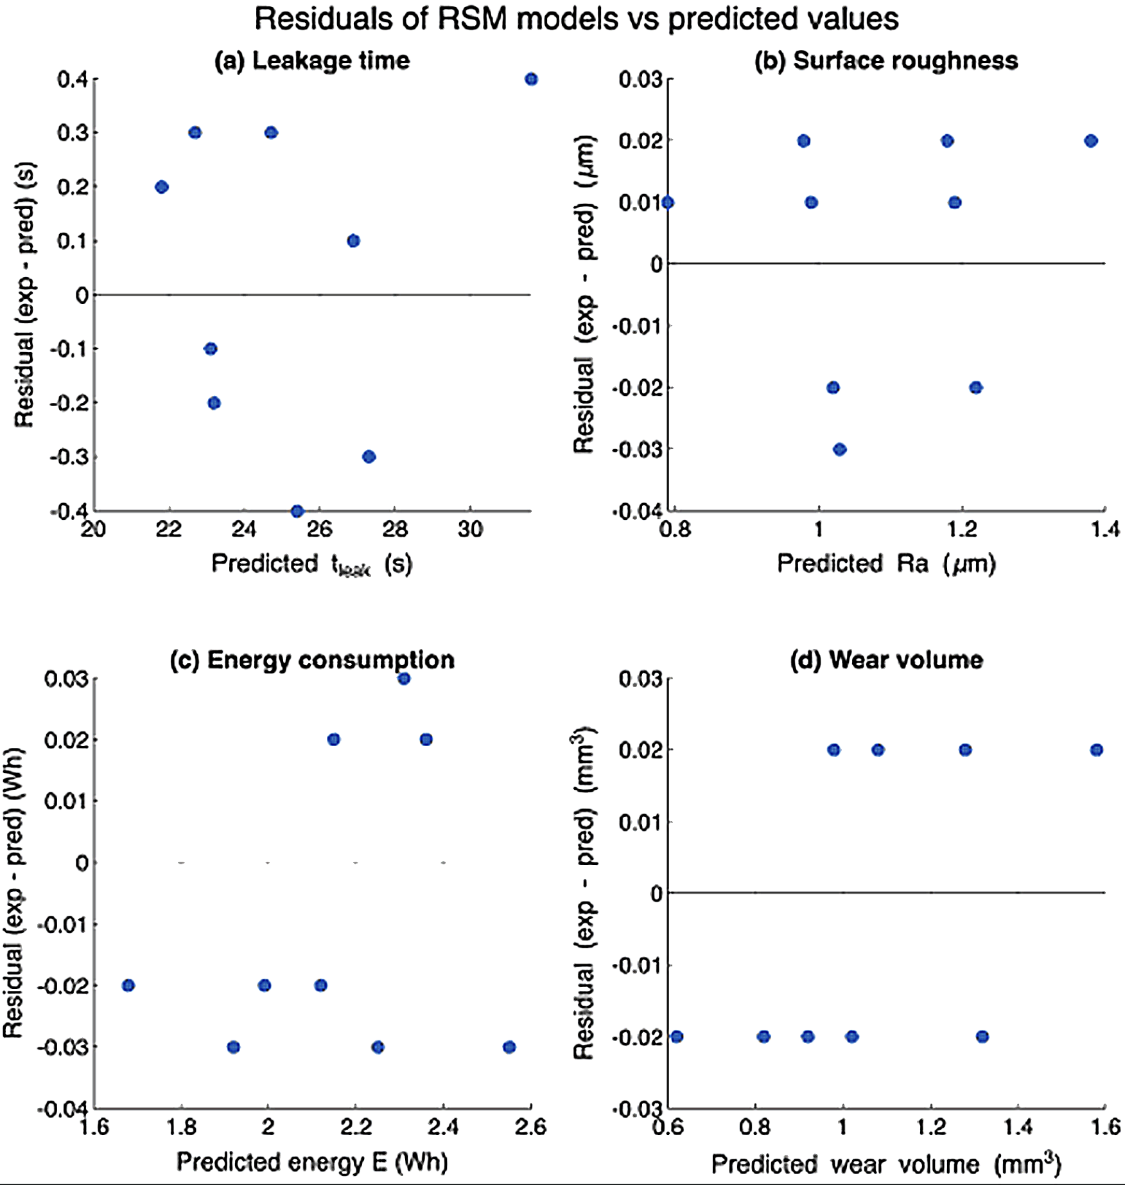
Fig. 5. Residuals between experimental and predicted responses as a function of the predicted values for (a) leakage time, (b) surface roughness Ra, (c) energy consumption, and (d) wear volume.

Fig. 5 presents the residual plots for the developed RSM models, showing the difference between experimental and predicted responses plotted against the corresponding predicted values for leakage time, surface roughness, energy consumption, and wear volume. Such plots are commonly used to assess the Adequacy of regression models beyond numerical goodness-of-fit metrics, as they allow potential systematic deviations, variance instability, or model bias to be visually identified. By examining the distribution and spread of the residuals across the prediction range, the suitability of the assumed quadratic response surfaces can be qualitatively evaluated prior to formal statistical testing.
Lack-of-fit tests are non-significant (p > 0.05) for all responses, indicating that the quadratic form is adequate within the investigated design space. As shown in Fig. 5, the residuals remain relatively small in magnitude over the entire range of predicted values: for leakage time, they lie within approximately ±0.4 s; for surface roughness, within ±0.03 µm; for energy consumption, within ±0.03 Wh; and for wear volume, within ±0.03 mm³. These values correspond to only a small fraction of the respective response ranges, so that the practical prediction error introduced by the models is limited. In addition, the residual plots do not reveal any systematic patterns, curvature, or funnel-shaped behaviour indicative of model misspecification or strong heteroscedasticity. The points are scattered in a roughly symmetric fashion around the zero line, and no individual run appears as an outlier with excessively large residuals. This suggests that the errors' variance is reasonably constant and that there is no obvious correlation between residuals and fitted values. Taken together with the high coefficients of determination obtained from the ANOVA tables (not shown here for brevity), these features support the validity of the regression assumptions. On this basis, the fitted RSM models are deemed suitable for subsequent physical interpretation and for use as surrogate functions in the multi-objective optimisation stage.

Effect of spindle speed and axial load on process responses

Leakage time (sealing performance)
To visualise the combined influence of spindle speed and axial load on sealing performance, the predicted leakage time obtained from the RSM model is illustrated in Fig. 6. Fig. 6 illustrates the predicted leakage time t_{leak}​ as a function of spindle speed and axial load in the form of a contour map and a three-dimensional response surface derived from the quadratic RSM model. These visualisations provide an intuitive representation of the combined influence of the two control parameters and facilitate the identification of regions associated with favorable sealing performance. By examining the shape of the response surface and the spacing of the contour levels, the presence of interaction effects and non-linear trends in leakage time can be qualitatively assessed prior to a detailed discussion of the experimental results.
The experimental leakage time results presented in Table 2, together with the corresponding response surface, demonstrate that sealing performance—as quantified by leakage time—is governed by a strong, non-linear interaction between spindle speed and axial load. For all three spindle speed levels, leakage time initially increases as the axial load is raised from 60 to 100 N, indicating improved sealing, but subsequently decreases when the load is further increased to 140 N. A comparable non-monotonic trend is observed for spindle speed: at a given axial load, leakage time is consistently highest at 450 rpm, moderate at 600 rpm, and lowest at 300 rpm.
The contour plot of tleakt_t_{leak}​ in the (x₁,x₂) plane reveals a pronounced ridge of maximum leakage time centred around the combination of 450 rpm and 100 N. This region corresponds to a balance between sufficient real contact area formation and the avoidance of excessive local damage or distortion of the valve seat band.
At lower axial loads (60 N), the contact pressure is insufficient to induce adequate plastic deformation of surface micro-asperities, resulting in a discontinuous sealing band and reduced leakage time. Conversely, at higher loads (140 N), the contact becomes overly aggressive, increasing the likelihood of local wear or micro-cracking, which again degrades sealing integrity and shortens leakage time despite the higher nominal contact pressure.

Surface roughness of the lapped seat
The combined effects of spindle speed and axial load on leakage time and surface roughness are visualised in contour maps shown in Fig. 7. Fig. 7 presents contour maps derived from the quadratic RSM models illustrating the combined effect of spindle speed and axial load on leakage time and surface roughness of the lapped valve seat. By placing the two responses in the same parameter space, the figure enables a direct visual comparison of their trends. It highlights regions where sealing performance and surface finish can be improved simultaneously. The contour representation facilitates the identification of non-linear effects and interaction behaviour between the process parameters prior to a detailed discussion of the underlying tribological mechanisms.
Surface roughness Ra follows trends consistent with tribological expectations for low-speed lapping. At all speeds, the lowest Ra values are observed at the intermediate axial load of 100 N, with minimum roughness obtained at 450 rpm and 100 N. At 60 N, the contact pressure is relatively low, the abrasive particles are not fully engaged, and the lapping action is less effective, resulting in slightly higher Ra values. At 140 N, the higher load promotes more intense micro-cutting and potential ploughing, which can again increase roughness and damage the surface topography.
The Ra response surface displays a clear valley region centred near 450 rpm and 100 N, similar to the leakage-time surface. The quadratic terms in the Ra model are significant for both factors, indicating that the relationship is not purely linear. The presence of a distinct minimum in Ra suggests that the system operates in a mild-wear regime near this optimum, whereas moving away from it pushes the contact into either an under-loaded "polishing" condition or a more aggressive wear mode [26].

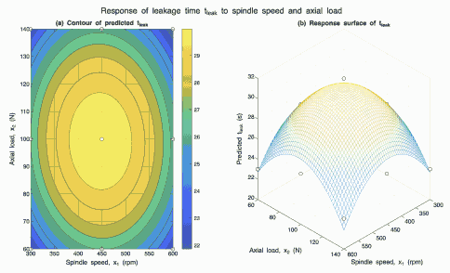
Fig. 6. Predicted leakage time $t_{leak}$ as a function of spindle speed and axial load: (a) contour map with experimental design points and (b) three-dimensional response surface obtained from the quadratic RSM model.

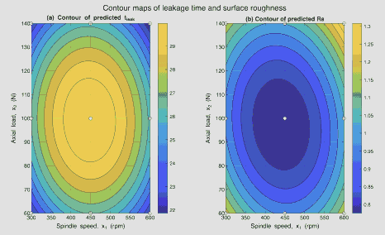
Fig. 7. Contour maps obtained from the quadratic RSM models showing the effect of spindle speed and axial load on (a) leakage time $t_{leak}$ and (b) surface roughness Ra.

Energy consumption
The influence of spindle speed and axial load on energy consumption is visualised using contour and response surface plots, as shown in Fig. 8. Fig. 8 presents the contour map and three-dimensional response surface of the predicted energy consumption as a function of spindle speed and axial load, as obtained from the quadratic RSM model. These representations provide a clear overview of how the process parameters influence the energetic behavior of the lapping operation across the investigated design space. The contour spacing and surface inclination offer qualitative insight into the sensitivity of energy consumption to changes in speed and load, thereby facilitating the identification of regions associated with higher or lower energy demand prior to a detailed interpretation of the underlying process mechanisms.
Energy consumption per lapping operation decreases monotonically with both spindle speed and axial load in the investigated range. At a fixed speed, increasing from 60 to 140 N reduces the lapping time required to achieve a given visual appearance and leakage performance, leading to lower energy use despite a somewhat higher operating current. Similarly, for a fixed load, increasing the speed from 300 to 600 rpm shortens the process time. It thus reduces energy consumption from approximately 2.5 Wh down to around 1.7 Wh in the most aggressive condition.
The response surface for energy does not exhibit an internal minimum but tends to favour the upper-right corner of the design space, i.e., high speed and high load. This is typical of many finishing processes where productivity and energy efficiency improve when more "aggressive" parameters are used, provided that quality and tool life remain acceptable [27]. In the present case, the most energy-efficient point coincides with conditions that are suboptimal from the perspective of wear and, to some extent, surface integrity.

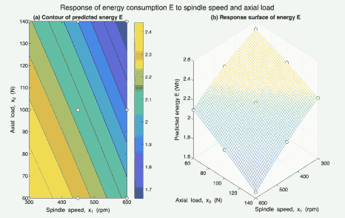
Fig. 8. Predicted energy consumption $E$ as a function of spindle speed and axial load.

Wear volume
The influence of spindle speed and axial load on wear volume is visualised using contour and response surface plots, as shown in Fig. 9. Fig. 9 presents the contour map and three-dimensional response surface of the predicted wear volume as a function of spindle speed and axial load, as obtained from the quadratic RSM model. These visualisations provide an overview of how the operating parameters influence material removal and component degradation across the investigated design space. By examining the overall shape of the response surface and the distribution of contour levels, the dominant trends and potential interaction effects in wear behavior can be identified prior to a detailed discussion of the underlying wear mechanisms.

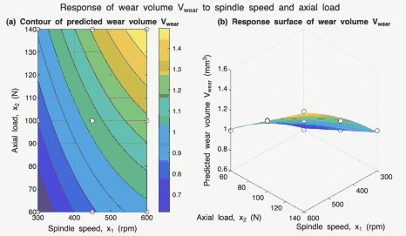
Fig. 9. Predicted wear volume $V_{wear}$ as a function of spindle speed and axial load.

Wear volume increases approximately monotonically with both spindle speed and axial load. The least wear is observed at 300 rpm and 60 N, while the greatest is recorded at 600 rpm and 140 N. The response surface is dominated by positive linear contributions of both factors, with additional curvature captured by the quadratic terms. These trends are consistent with Archard-type wear behaviour, where volume loss is proportional to the product of normal load and sliding distance, both of which increase with axial load and speed in the present set-up [28].
From a practical standpoint, higher speeds and higher loads remove material more rapidly. They can help correct severe seat defects, but at the cost of greater dimensional loss and shorter component life. For standard reconditioning tasks with moderate initial damage, the observed wear trends underscore the need to limit both spindle speed and load if dimensional preservation is a priority.

Trade-offs between tribological performance, energy, and wear
To facilitate a direct comparison between the different process responses at a fixed axial load, the normalised response curves as a function of spindle speed are shown in Fig. 10. Fig. 10 presents the normalised responses of leakage time, surface roughness, energy consumption, and wear volume evaluated along a one-dimensional process line at a fixed axial load of 100 N. By normalising the responses to a common scale and plotting them as a function of spindle speed, the figure enables a direct comparison of trends among performance, efficiency, and wear-related metrics under identical loading conditions. This representation provides a clear visual framework for identifying potential conflicts and compromises between the different objectives before a detailed multi-response interpretation is undertaken. The combined interpretation of the four normalised curves in Fig. 10 highlights how tribological performance, energy use, and wear compete even at a fixed axial load of 100 N. The leakage time $t_{leak}$ exhibits a concave profile with a clear maximum around 450 rpm, while the roughness $R_{a}$ shows the opposite trend, reaching its minimum at essentially the same speed. This indicates that an intermediate speed region provides the most favourable contact conditions for forming a continuous sealing band with low surface irregularity. In contrast, the energy consumption $E$ decreases almost monotonically with increasing speed, because a higher spindle speed shortens the lapping time required to achieve a given number of sliding cycles. The wear volume $V_{wear}$ follows an opposing trend: at low speed (around 300 rpm), the wear is minimal, but it increases steadily as speed rises towards 600 rpm, reflecting more aggressive sliding and higher cumulative frictional work at the interface.
These patterns reveal a classic multi-objective conflict. Moving towards higher speed reduces the specific energy per operation but simultaneously increases wear and tends to deteriorate surface finish, whereas moving towards lower speed reduces wear and can preserve geometry but leads to longer processing times, higher energy usage, and shorter leakage times, which translate into poorer sealing. Operating near intermediate speeds around 430–470 rpm, therefore, provides a balanced compromise, with long leakage times, low $R_{a}$ and only moderate penalties in energy and wear. Such trade-offs are typical of finishing and lapping operations, where removing just enough material while generating an adequate surface texture is essential and both under-processing and over-processing are undesirable [28], [29]. The RSM framework makes these interactions quantitatively explicit and underlines that no single "best" operating point exists in isolation; instead, the choice of spindle speed must be guided by the relative importance assigned to sealing performance, surface integrity, energy efficiency, and component life.

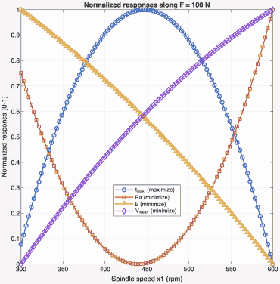
Fig. 10. Normalised responses of leakage time $t_{leak}$, surface roughness Ra, energy consumption $E$and wear volume $V_{wear}$along the process line at $F=100 N$as a function of spindle speed.

Multi-objective optimisation and Pareto analysis
The trade-offs between the different process objectives are visualised using Pareto fronts, as shown in Fig. 11. Fig. 11 illustrates the Pareto-optimal trade-offs obtained from the RSM-based multi-objective optimisation, showing the relationships between leakage time, energy consumption, surface roughness and wear volume. The visualisations provide a graphical representation of the non-dominated solution set and highlight the inherent conflicts between performance, efficiency and durability-related objectives. By examining the structure and extent of the Pareto front in the relevant objective spaces, the range of feasible compromises within the investigated design space can be identified before a detailed discussion of representative operating conditions.
To systematically explore these trade-offs, the four RSM models were coupled with the NSGA-II algorithm, treating spindle speed and axial load as decision variables and using leakage time, surface roughness, energy consumption and wear volume as simultaneous objectives. The resulting Pareto front represents a family of non-dominated operating points where no objective can be improved without worsening at least one of the others.
The Pareto solutions are distributed across both the interior and the boundaries of the design space. At the front extreme, sealing-dominated solutions cluster around spindle speeds of approximately 430–470 rpm and axial loads near 100 N, where leakage time is maximised and Ra is close to its minimum. At the same time, energy consumption and wear remain moderate. At the other extreme, energy-dominated solutions favour high speeds and high loads (close to 600 rpm and 140 N), which minimise electrical energy per lapping cycle but increase wear and slightly reduce sealing performance. Conversely, wear-dominated solutions occur at low speeds and low loads (around 300 rpm and 60 N), where valve wear is minimised at the expense of shorter leakage times and higher energy use. Between these extremes, a continuum of compromise points populates the Pareto front, offering different balances between sealing quality, surface integrity, energy efficiency and wear.

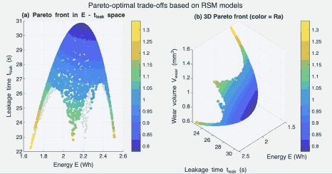
Fig. 11. Pareto-optimal trade-offs between leakage time, energy consumption, surface roughness and wear volume obtained from the RSM-based multi-objective optimisation.

The relative performance of selected Pareto-optimal solutions is compared using normalised response values, as shown in Fig. 12. Fig. 12 presents a normalised comparison of three representative Pareto-optimal solutions selected from the multi-objective optimisation results. By scaling all responses to a common dimensionless range, the figure provides a concise visual framework for contrasting operating points that prioritise different objectives. This representation allows the relative strengths and weaknesses of sealing, energy, and wear-oriented solutions to be assessed consistently before a detailed interpretation of each case is discussed. Fig. 12 compares three representative Pareto solutions, denoted A, B and C, in terms of the four normalised responses. For clarity, each response is scaled to 0–1, so the relative performance of the three operating points can be directly compared. A higher normalised value of $t_{leak}$ is desirable, whereas lower normalised values of Ra, $E$ and $V_{wear}$ correspond to better surface finish, lower energy consumption and lower wear, respectively.
Solution A (sealing-oriented) corresponds to an operating point near 450 rpm and 100 N. In the normalised plot it exhibits the highest value of $t_{leak}$ and the lowest Ra among the three candidates, indicating superior sealing performance and surface integrity. Its energy consumption and wear volume are intermediate, indicating that good sealing can be achieved without pushing energy use or wear to extreme levels.
Solution B (energy-oriented) is located towards the high-speed, high-load corner of the design space (approximately 600 rpm and 140 N). This solution achieves the lowest normalised energy, confirming it as the most energy-efficient operating point. However, it also shows the highest Ra and the highest $V_{wear}$, together with the lowest $t_{leak}$, which implies a clear penalty in sealing quality and component life when energy savings are prioritised.
Solution C (wear-oriented) lies close to the low-speed, low load corner (around 300 rpm and 60 N). It attains the lowest normalised wear volume, indicating minimum material removal from the valve face. Ra and $t_{leak}$ take intermediate values between Solutions A and B, while the energy requirement is the highest of the three. This operating point therefore favours valve longevity at the expense of higher energy consumption and only moderate sealing performance.
Taken together, these three solutions illustrate the structure of the Pareto front: it is not possible to maximise leakage time, minimise roughness, minimise energy consumption and minimise wear simultaneously. Instead, the chart provides a compact visual guide for practitioners to select operating conditions based on whether sealing quality, energy efficiency, or component life is the dominant design priority.

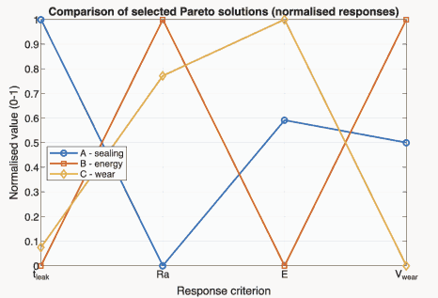
Fig. 12. Normalised comparison of three representative Pareto solutions: A (sealing-focused), B (energy-focused) and C (wear-focused).

Practical implications for valve seat reconditioning
The recommended operating regions in the spindle speed–axial load space are illustrated in Fig. 13. Fig. 13. summarises the results of the multi-objective optimisation in the form of recommended operating regions in the spindle speed–axial load plane. By mapping the representative Pareto solutions and their associated performance characteristics onto the process parameter space, the figure translates the abstract Pareto front into an intuitive operating map that can be readily interpreted in a workshop context. The highlighted regions indicate parameter combinations that preferentially favour sealing performance, energy efficiency, or wear minimisation, thereby providing a practical framework for selecting operating conditions according to the dominant maintenance objective.

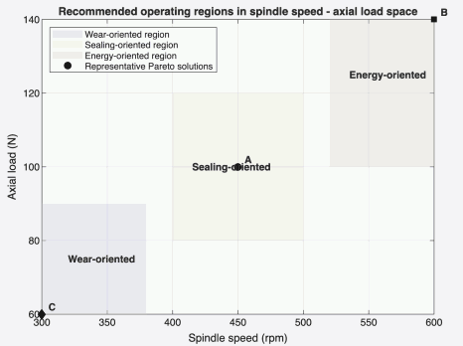
Fig. 13. Recommended operating regions in spindle speed–axial load space for the automatic valve lapping machine.

From the standpoint of engine maintenance, the combination of experimental characterisation, RSM modelling, and NSGA-II optimisation yields several practical recommendations: (1) for standard valve-seat reconditioning, operating conditions should be chosen within the sealing-oriented region, i.e., around intermediate speeds and loads (approximately 430–470 rpm and 90–110 N), where leakage time is high, Ra is low and both energy consumption and wear remain at moderate levels; (2) when sealing quality and surface finish are prioritised, the results support operating close to Solution A (about 450 rpm and 100 N), which represents a robust setting within the sealing-oriented window; (3) highly aggressive settings at high speed and high load (around 600 rpm and 140 N, close to Solution B) should be reserved for severely damaged seats or coarse reconditioning stages, because they reduce energy per cycle but significantly increase Ra and wear; (4) low-speed, low-load conditions (around 300 rpm and 60 N, close to Solution C) are better suited for final, wear-conscious finishing passes on critical components than for routine overhaul, as they minimise wear but require higher energy and provide only moderate sealing performance.
These guidelines show that, even for a relatively simple, low-cost Arduino-based lapping rig, a systematic, data-driven analysis can be translated into a clear operating map for selecting spindle speed and axial load based on the dominant objective in workshop practice. In contrast to many previous studies that focus on isolated surface quality metrics or abstract optimisation benchmarks, the present work integrates tribological performance, energy consumption, and wear into a unified experimental and optimisation framework for valve lapping. By combining low-cost experimental Instrumentation with RSM-based surrogate modelling and NSGA-II optimisation, this study extends the existing literature by providing application-oriented operating guidelines that directly support workshop-level decision-making.

Conclusions
This work presented the development and optimisation of an automatic valve lapping machine for reconditioning engine valve seats. A full 3² factorial design in spindle speed and axial load enabled identification of quadratic response surface models for all four responses. Analysis of variance and residual diagnostics indicate non-significant lack of fit, small residuals, and high coefficients of determination. These results confirm that the second-order models adequately capture the dominant tribological and energy-related effects within the investigated range; extrapolation beyond this domain should be treated cautiously. Response surfaces and normalised one-factor plot at F = 100 N reveal trade-offs among sealing performance, surface integrity, energy use, and wear. Leakage time and surface roughness exhibit optima at intermediate speeds, while energy consumption decreases and wear increases with increasing speed. Thus, neither very low nor very high speeds are universally favourable. Operating conditions of approximately 430–470 rpm and 90–110 N provide a robust compromise, delivering long leakage times and low roughness with moderate energy and wear penalties. Coupling the RSM models with NSGA-II produced a Pareto front quantifying trade-offs among the four objectives. Representative Pareto solutions were used to construct a practical operating map in the spindle speed–axial load plane, offering recommended regions depending on priority (sealing quality, energy efficiency, or component life). Overall, the study demonstrates that a simple Arduino-based rig combined with experimental design, response surface modelling, and evolutionary optimisation can serve as a quantitative decision tool for lapping operations, linking sealing performance, surface roughness, energy consumption, and wear within a validated framework. The Pareto-based operating maps replace trial-and-error parameter selection with data-driven guidelines under practical constraints.

References
- J. B. Heywood, Internal Combustion Engine Fundamentals, 2nd ed. New York, NY, USA: McGraw–Hill, 2018.
- D. C. Montgomery, Design and Analysis of Experiments, 9th ed. Hoboken, NJ, USA: John Wiley & Sons, 2017.
- Hutchings, I. (1992). Tribology: Friction and Wear of Engineering Materials. https://doi.org/10.1016/0261-3069(92)90241-9.
- Delgarm, N., Sajadi, B., Delgarm, S., & Kowsary, F. (2016). A novel approach for the simulation-based optimization of the building's energy consumption using NSGA-II: Case study in Iran. Energy and Buildings, 127, 552-560. https://doi.org/10.1016/j.enbuild.2016.05.052.
- K. Holmberg, P. Andersson, and A. Erdemir, "Global energy consumption due to friction in passenger cars," Tribology International, vol. 47, pp. 221–234, 2012. https://doi.org/10.1016/j.triboint.2011.11.022
- K. Holmberg and A. Erdemir, "Influence of tribology on global energy consumption, costs and emissions," Friction, vol. 5, no. 3, pp. 263–284, 2017.
- Z. Deng, J. Wang, C. Li, X. You, and L. Wang, "Optimization of lapping parameters of single-crystal silicon carbide using response surface methodology," Micromachines, vol. 12, no. 6, 2021.
- A. Mandal, G. K. Singh, and R. Sood, "Multi-objective optimization of EDM performance on Monel K-500 alloy using RSM and NSGA-II," Scientific Reports, vol. 14, 2024.
- M. A. Kafaj, R. T. Setyawan, and S. Umira, "Effect of LAKSAMANA V2 electric vehicle battery performance on vehicle speed and load variations using Simulink," J-TETA, vol. 4, no. 2, pp. 80–86, Oct. 2025, (in Indonesian). https://doi.org/10.25047/jteta.v4i2
- J. Zhang, C. Li, Y. Wu, W. Zhao, and S. Zhang, "Multi-objective optimization of medium-speed WEDM process using response surface methodology and NSGA-II," Int. J. Adv. Manuf. Technol., vol. 72, pp. 883–898, 2014.
- P. S. Bharti, S. S. Mahapatra, and H. Singh, "Multi-objective optimization of electric discharge machining process using controlled elitist NSGA-II," J. Mech. Sci. Technol., vol. 26, no. 6, pp. 1875–1884, 2012. https://doi.org/10.1007/s12206-012-0411-x
- X. Yang and U. Natarajan, "Multi-objective optimization of cutting parameters in turning using differential evolution and NSGA-II," Int. J. Adv. Manuf. Technol., vol. 49, pp. 773–784, 2010.
- T. Nguyen, D. Nguyen, D. Tran, and T. Pham, "Hybridization of machine learning models with NSGA-II for multi-objective optimization of machining processes," J. Mach. Eng., vol. 23, no. 1, pp. 42–58, 2023.
- R. T. Setyawan, I. Hajar, and G. Gunawan, "Full-model electric vehicle modeling and simulation for analysis of suspension and regenerative braking interaction," JTM, vol. 22, no. 2, pp. 108–116, Oct. 2025, (in Indonesian). https://doi.org/10.9744/jtm.22.2.108-116
- F. Lai et al., "A comparison of wear behaviour of heat-resistant steel engine valves and TiAl engine valves," Proc. Inst. Mech. Eng. Part J: J. Eng. Tribol., vol. 234, no. 10, pp. 1549–1562, 2020. https://doi.org/10.1177/1350650119872093
- K. Siczek, "Influence of operating factors on the behaviour of the combustion engine valve timing system," Combustion Engines, vol. 201, no. 2, pp. 11–18, 2025. https://doi.org/10.19206/CE-204320
- K. Deb, A. Pratap, S. Agarwal, and T. Meyarivan, "A fast and elitist multi-objective genetic algorithm: NSGA-II," IEEE Trans. Evol. Comput., vol. 6, no. 2, pp. 182–197, 2002. https://doi.org/10.1109/4235.996017
- R. T. Setyawan, S. Umira, I. Kurniawan, G. Gunawan, and E. Muthoriq, "Distributed temperature sensing and fault-tolerant logging for PVC-based smoke condensers using dual-channel type-K sensors," Jurnal Polimesin, vol. 23, no. 4, 2025.
- A. Afriansyah, M. N. Siregar, and R. Kurniawan, "Analysis of machining parameters in side milling of AISI 1045 steel using Response Surface Methodology (RSM)," J. Rekayasa Mesin, vol. 12, no. 3, pp. 203–212, 2021, (in Indonesian). https://doi.org/10.36706/jrm.v21i1.88
- Y. Kurniawan, "Application of the response surface method in the decomposition process of zircon sand using an electric furnace," MACHINE: Jurnal Teknik Mesin, vol. 4, no. 2, pp. 67–74, 2018, (in Indonesian). https://doi.org/10.33019/jm.v4i1.445
- M. Muddin and D. Prasetyo, "Optimization of injection moulding machine process parameters using response surface methodology," ELEMEN: Jurnal Teknik Mesin, vol. 10, no. 1, pp. 1–10, 2023.
- X. Le and M. L. Peterson, "Material Removal Rate in Flat Lapping," Journal of Manufacturing Processes, vol. 1, no. 1, pp. 71–78, 1999, https://doi.org/10.1016/S1526-6125(99)70007-1.
- L. S. Deshpande, S. Raman, O. Sunanta, and C. Agbaraji, "Observations in the flat lapping of stainless steel and bronze," Wear, vol. 265, nos. 1–2, pp. 105–116, 2008, https://doi.org/10.1016/j.wear.2007.09.004
- H. Bachtiar and W. Sutopo, "Multi-response optimization of machining processes using a desirability function approach," Jurnal Teknik Mesin, vol. 15, no. 2, pp. 87–94, 2013, (in Indonesian).
- R. Gunawan and S. Hidayat, "Optimization of turning machining parameters using RSM to improve surface quality," Jurnal Ilmiah Teknik Mesin, vol. 9, no. 1, pp. 15–24, 2022, (in Indonesian).
- Babajamali, Z., Khabaz, M., Aghadavoudi, F., Farhatnia, F., Eftekhari, S., & Toghraie, D. (2022). Pareto multi-objective optimization of tandem cold rolling settings for reductions and interstand tensions using NSGA-II. ISA transactions. https://doi.org/10.1016/j.isatra.2022.04.002.
- Fu, L., Zhao, M., Wu, P., Wen, J., Qiu, Y., Liao, L., Zhu, W., & Wang, L. (2025). Geometric multi-objective optimization of a microchannel-pinfin hybrid heat sink. International Journal of ThermalSciences.https://doi.org/10.1016/j.ijthermalsci.2025.109711.
- Yang, M., Zhang, Y., Ai, C., Yan, G., & Jiang, W. (2023). Multi-objective optimisation of K-shape notch multi-way spool valve using CFD analysis, discharge area parameter model, and NSGA-II algorithm. Engineering Applications of Computational FluidMechanics,17. https://doi.org/10.1080/19942060.2023.2242721.
- Cheraghi, R., & Jahangir, M. (2023). Multi-objective optimization of a hybrid renewable energy system supplying a residential building using NSGA-II and MOPSO algorithms. Energy Conversion and Management. https://doi.org/10.1016/j.enconman.2023.117515.
- Verma, S., Pant, M., & Snás̃el, V. (2021). A Comprehensive Review on NSGA-II for Multi-Objective Combinatorial Optimization Problems. IEEE Access, 9, 57757-57791. https://doi.org/10.1109/access.2021.3070634.
- Hosamo, H., Tingstveit, M., Nielsen, H., Svennevig, P., & Svidt, K. (2022). Multi-objective optimization of building energy consumption and thermal comfort based on integrated BIM framework with machine learning-NSGA II. Energy and Buildings. https://doi.org/10.1016/j.enbuild.2022.112479.
- Remache, A., Pérez-Sánchez, M., Hidalgo, V., & Ramos, H. (2025). Hybrid Optimization Approaches for Impeller Design in Turbomachinery: Methods, Metrics, and Design Strategies. Water. https://doi.org/10.3390/w17131976.
- C. Agbaraji and S. Raman, "Basic observations in the flat lapping of aluminum and steels using standard abrasives," Int. J. Adv. Manuf. Technol., vol. 44, pp. 293–305, 2019, https://doi.org/10.1007/s00170-008-1827-4.

